**NAVISTAR, INC.**

**Navistar, Inc.**

**MS-D-13**

**Supplier Containerization/Packing and Shipping Standard**

**Revision 20.0**

|  |  |  |
| --- | --- | --- |
| **NAVISTAR, INC**. | | |
| **Supply Chain Standards** | | *NUMBER:*  **PUR - 3003** |
| *TITLE:*  **Supplier Containerization /Packing and Shipping Standard** | | *Current Issue Date*  **March 12, 2018 ver 20.0** |
| *WRITTEN/REVIEWED BY:* **Mike Priaulx** | *APPROVED BY:*  **Pietro Salaverry** | *SUPERSEDES ISSUE OF:*  **March 1, 2016 ver 19.0** |
| **PRINTED COPIES OF THIS DOCUMENT MUST BE VERIFIED FOR CURRENT REVISION** | | |

**TABLE OF CONTENTS**

[1.0 SCOPE 1](#_Toc237833335)

[2.0 PURPOSE 1](#_Toc237833336)

[3.0 PACKING\* 1](#_Toc237833337)

[3.1 Established Packing Method 1](#_Toc237833338)

[3.2 Material Handling Requirements 2](#_Toc237833339)

[3.3 Acceptable Containers: (includes guidelines for 3rd party container management supplier) 3](#_Toc237833340)

[3.4 Restricted Containers 5](#_Toc237833341)

[3.5 Special Handling Requirements 5](#_Toc237833342)

[4.0 IDENTIFICATION OF MATERIALS 8](#_Toc237833343)

[4.1 Method of Identification 8](#_Toc237833344)

[4.2 Data Area Characteristics 9](#_Toc237833345)

[4.3 Bar Code Symbology 10](#_Toc237833346)

[4.4 Label Location and Protection 11](#_Toc237833347)

[4.5 Special Labels 11](#_Toc237833348)

[4.6 Supplier Owned Returnable Containers 14](#_Toc237833349)

[4.7 Standard Navistar Pallets and Containers 14](#_Toc237833350)

[4.8 Export 14](#_Toc237833351)

[4.9 Identification of Indirect Materials 14](#_Toc237833352)

[5.0 PRESERVATION AND PACKAGING 14](#_Toc237833353)

[5.1 Preservation 15](#_Toc237833354)

[5.2 Packaging 15](#_Toc237833355)

[6.0 SHIPPING 16](#_Toc237833356)

[6.1 Mode of Transportation 16](#_Toc237833357)

[6.2 Consolidation 16](#_Toc237833358)

[6.3 Loading 16](#_Toc237833359)

[6.4 Packing List 18](#_Toc237833360)

[6.4.A Pallet Example 19](#_Toc237833361)

[6.4.B Service Parts - Pallet Manifest 20](#_Toc237833362)

[6.5 Transportation Regulations 21](#_Toc237833363)

[6.6 Material Labeling 21](#_Toc237833364)

[7.0 REFERENCES 22](#_Toc237833365)

[7.1 Organizations and Websites 22](#_Toc237833366)

[7.2 Referenced Documents 22](#_Toc237833367)

[7.3 Navistar Inc. Locations 23](#_Toc237833368)

**APPENDIX**

[1.0 NAVISTAR STANDARD CONTAINERS 24](#_Toc239581617)

[1.1 Introduction 24](#_Toc239581618)

[1.2 Choices of Shipping Devices/Containers 24](#_Toc239581619)

[1.3 Selection and Approval 25](#_Toc239581620)

[1.4 Interior Packaging 25](#_Toc239581621)

[1.5 Transportation 26](#_Toc239581622)

[1.6 Credit for Return 26](#_Toc239581623)

[1.7 Repair and Cleanliness 26](#_Toc239581624)

[1.8 Standard Shipping Bundles 27](#_Toc239581625)

[1.9 Shipping Devices 27](#_Toc239581626)

[2.0 SHIPPING ABBREVIATIONS, TERMS AND DATA IDENTIFIERS 29](#_Toc239581627)

[2.1 Abbreviations 29](#_Toc239581628)

[2.2 Definition of Terms 29](#_Toc239581629)

[2.3 Bar Code Identifiers or ABR Identifiers 30](#_Toc239581630)

[2.4 Recommended Data Order 30](#_Toc239581631)

[3.0 SHIPPING/ RETAIL LABEL EXAMPLES 31](#_Toc239581632)

[Example 3.1 – Shipping Label 31](#_Toc239581633)

[Example 3.2 – Master Label 32](#_Toc239581634)

[Example 3.3 – Mixed Load 33](#_Toc239581635)

[Example 3.4 – Service Retail Label (RP801C) 33](#_Toc239581636)

[Example 3.5 - Truck –Shipping Label -Special Data Area: 34](#_Toc239581637)

[4.0 QUICK RECEIVE LABEL 35](#_Toc239581638)

[Example 4.1 – Quick Receive Label 35](#_Toc239581639)

[5.0 ABR LABEL EXAMPLES 35](#_Toc239581640)

[Example 5.1. - ABR Container Label: 35](#_Toc239581641)

[Example 5.2. - ABR Part Label: 36](#_Toc239581642)

[Example 5.3 - ABR Container Label: 37](#_Toc239581643)

[6.0 LABEL LOCATIONS ON VARIOUS SHIPPING PACKS 38](#_Toc239581644)

[6.1 Exhibit - BOX OR CARTON 38](#_Toc239581645)

[6.2 Exhibit - CARTONS ON PALLET 38](#_Toc239581646)

[6.3 Exhibit - DRUMS, BARRELS, OR CYLINDRICAL CONTAINERS 38](#_Toc239581647)

[6.4 Exhibit – BALES 38](#_Toc239581648)

[6.5 Exhibit - BASKET, WIRE MESH CONTAINER 39](#_Toc239581649)

[6.6 Exhibit - METAL BIN OR TUB 39](#_Toc239581650)

[6.7 Exhibit - PALLET BOX 39](#_Toc239581651)

[6.8 Exhibit - TELESCOPIC OR SET-UP CONTAINERS 39](#_Toc239581652)

[6.9 Exhibit - BUNDLE 40](#_Toc239581653)

[6.10 Exhibit – BAG 40](#_Toc239581654)

[6.11 Exhibit – ROLL 40](#_Toc239581655)

[6.12 Exhibit – RACK 40](#_Toc239581656)

[7.0 CTDR – ROUTING & SHIPPING INSTRUCTIONS 41](#_Toc239581657)

[7.1 See Navistar Inc. Routing Instructions (CTDR-1) 41](#_Toc239581658)

[7.2 Bill of Lading Requirements, Domestic 41](#_Toc239581659)

[7.3 BILL OF LADING REQUIREMENTS, CONSIGNMENTS TO CONSOLIDATION CENTERS 42](#_Toc239581660)

[7.4 BILL OF LADING REQUIREMENTS – DIRECT SHIPMENTS 42](#_Toc239581661)

[7.5 DOCUMENTATION REQUIREMENTS - IMPORT/EXPORT 42](#_Toc239581662)

[7.6 DESTINATION LABELING 42](#_Toc239581663)

[7.7 SAMPLE UNIFORM STRAIGHT B/L \* 43](#_Toc239581664)

[7.8 SAMPLE UNIFORM STRAIGHT B/L SHORT FORM \* 44](#_Toc239581665)

[8.0 VOLATILE CORROSION INHIBITORS 45](#_Toc239581666)

[8.1 DEFINITION 45](#_Toc239581667)

[8.2 INHIBITOR PROPERTIES 45](#_Toc239581668)

[8.3 CARRIER 45](#_Toc239581669)

[8.4 TOXICITY 45](#_Toc239581670)

[8.5 APPLICATION 45](#_Toc239581671)

[8.6 CLEANING 46](#_Toc239581672)

[8.7 EFFECT ON NON-FERROUS MATERIALS 46](#_Toc239581673)

[8.8 PRACTICE CORRECT PROCEDURES WITH VCI 46](#_Toc239581674)

[APPENDIX FOR NAVISTAR, INC. ENGINE GROUP SUPPLIER GUIDE 47](#_Toc239581675)

[ELECTRONIC DATA (Element 1.0) 47](#_Toc239581676)

[LOGISTICS (Element 2.0) 48](#_Toc239581677)

[TRANSPORTATION (Element 3.0) 50](#_Toc239581678)

[PACKAGING AND LABELING (Element 4.0) 52](#_Toc239581679)

[MASTER SCHEDULING (Element 5.0) 56](#_Toc239581680)

[SUPPLIER CHARGEBACK POLICY (Element 7.0) 58](#_Toc239581681)

[NAVISTAR, INC. PACKAGING APPROVAL FORM (SERVICE ONLY) FOR PARTS OVER 100 LBS 59](#_Toc239581682)

CHEP PROVIDED RETURNABLE PACKAGING…………………………………………………………..60

# 1.0 SCOPE

This standard describes the containerization, packing procedures, identification methods, and location principles that Navistar Inc. requires suppliers to use when shipping products to Navistar operations within the continental U.S.A, Canada, and Mexico. Acceptance of an order or contract to supply products will be understood as an agreement by the supplier to be governed the specifications herein.

# 2.0 PURPOSE

The objective of this standard is to provide suppliers with general containerization, packing and shipping instructions instructions (specific part number container approval requires submission of Navistar Container Specification Form)so that products will arrive at Navistar locations free from damage at the lowest cost and in the form most acceptable to Navistar material handling practices.

# 3.0 CONTAINERIZATION - PACKING\*

Navistar and the supplier will work together to develop the container and packing method, the supplier when shipping will be responsible for ensuring that the container and packing conforms to this standard. The supplier is responsible for developing and submitting both the Primary and Alternate Container proposals. An approved Container Specification form is a required element of the PPAP package. Suppliers must have a Navistar approved Container Specification Form included in all PPAP submissions.

## 3.1 Established Packing Method

At the time of each bid, suppliers of materials to Navistar locations will detail proposed packing, both returnable and expendable on the CSF - Container Specification Form (SCS-CD-001) submitted to the appropriate delegated Navistar Containerization representitive. The Container Specification Form is a requirement of the RFQ and PPAP processes.The supplier will give prior notice to the receiving location of initial shipments and utilize the Container Test Shipment process, after being advised by the Navistar containerization representitive that the packing and shipping method are acceptable the supplier is authorized to follow the approved Container Specification Form for all production shipments.

Once a container, packing and shipping method has been established any change in the container, packing or points of shipment must have approval from the Navistar containerization manager who will have received concurrence from the Supply Chain Manager of the receiving location before the change is affected.

**\*Note**: The terms “container”, “packaging” and “packing” are often used interchangeably. For purpose of this standard a distinction is made. Packaging refers to the containers interior wraps, dunnage, and cushioning material that are ordinarily provided with an outer container when prepared for shipment. Container refers to the exterior containers’ blocking, bracing, tote, bulk box and pallets, which are used for shipping the product.

## 3.2 Material Handling Requirements

### 3.2.1 Size and Weight Limitations

Generally, the layout of aisles, storage, and work areas in Navistar locations is based on standard size containers, pallets, and racks. See Appendix Section 1.2 for acceptable size and types of materials.

The maximum gross weight of loads shipped to Navistar locations will not exceed 3,800 pounds per pallet (1,725 kilos) at 24 inch (60 cm) load centers unless approved by a Supply Chain Manager.

Unitized load heights should be held to a 33” (83 cm) maximum where sizes of material permit. Width of load should be equal to or greater than the load height.

Some Navistar material handling and storage systems preclude the used of the standard container size shown in Section 1 of the Appendix. Suppliers will contact the Supply Chain Manager of the receiving location before shipping any material to determine if there are any limitations as to weight or size of loads imposed by local systems and procedures beyond those contained in this standard. For a complete list of Navistar Corporation’s, locations see Section 7.3 Navistar Locations for more information.

**Maximum load allowable on plastic pallets and large 48” x 45” (122cm x 144cm) plastic pallet boxes is 2,500 pounds (1,135 Kilos),**

Small 32 x 30 (81cm x 76cm) plastic pallet boxes are 1,800 pounds (817 Kilos).

**Maximum load allowable in plastic hand totes is 35 pounds gross weight (13.61 Kilos),**

Maximum height of 1/16th modular boxes (totes) is 6 layers \*\*

Maximum height of 1/8th modular boxes (totes) is 5 layers \*\*

\*\*Subject to weight restrictions of 2,500 pounds (1,135 Kilos).

### 3.2.2 Storage

When the quantity of material is significant, the material may be placed in bulk or unracked storage at their receiving location; thus, the container or pack will be sufficiently strong and stable to permit stacking 12 feet (3.68 M) in height. Suppliers will check with the Supply Chain Manager at the receiving location to determine the height that the part will be stacked in storage. Sides of corrugated fiberboard boxes (if no other type container is available) may need stiffeners to prevent buckling or bursting. All pallets will require a minimum of three (3) bottom boards to distribute the load on the .lower packs. When a load cannot support identical loads, or when only one or two packs are shipped at one time, the loads must be able to fit into storage racks or be free stacked. This means that even though you could bulk ship parts such as insulation, Navistar must be able to free stack up to 12 feet, (say, against the wall) each individual carton cannot exceed 45” in height. In the event you are not free stacking, instead you are using racking, the cartons cannot be in excess of 45”. This maximum individual carton height is pointed out in stacking heights and Special Considerations Section.

### 3.2.3 Strength of Load

Packaged or bulk material will be fastened securely to a pallet with straps (~~steel or~~ plastic) or wrap (stretch or shrink) so that the load will not shift from vibration of transportation and handling. The top surface of the load, if possible, will be flat and level for stacking. Posts or other dunnage will be added if the parts or packages are not strong or level enough to support more loads of the same materials. Place separators between layers and covers on top as necessary to stabilize the load. All containers must allow eight (8) feet stacking of identical parts for truckload shipments. No steel banding, No stretch/shrink wrap

### 3.2.4 Mixed Part Numbers

If the quantity shipped of a part number is not sufficient to form a complete pallet load, that part number will be put on a pallet with other part numbers. However, no part number will appear in more than one mixed pallet in one shipment. When more than one part number is included in a pallet, a **“MIXED”** load label will be affixed to the load as described in Section 3.0, example 3.3, of the Appendix. The label will conform to the Automotive Industry Action Group’s (AIAG) Trading Partner Labels Implementation Guideline (B-10 Standard) with the word “MIXED” in 1-inch letters or larger. Prepare a separate list of all part numbers in the mixed load and insert in or affix on the mixed load where it can be readily seen.

All separate part numbers on a mixed load must be visible on the outside of the unit load. More than one part number in a Wire Basket or Bulk Box is not acceptable.

## 3.3 Acceptable Containers: (includes guidelines for 3rd party container management supplier)

### 3.3.1 Returnable Containers

The owner, whether shipper or receiver, controls a returnable container. Security deposits are subject to agreement and are valid only with the approval of the appropriate delegated Navistar buyer and the Supply Chain Manager of the receiving location. Navistar supports the use of plastic returnable containers whenever possible. Wire mesh baskets, metal racks and wood pallets or boxes may be used where plastic will not suffice. Neither wire mesh nor plastic containers are permitted for shipments to Service Parts operations, contract packagers, or Tier 2 suppliers without Supply Chain Management Group, buyer, and service parts packaging written approval. For clarification purposes, a Tier 2 is a supplier to the Tier 1 supplier and is not authorized to receive or use any Navistar returnable container in the assembly process.

It is the understanding that the Truck Group will **NOT** provide, fund, or manage WIP (Work-in-process) and/or designated Tier 2 supplier containerization to the supplier base.

### 3.3.2 Plastic Containers

Only containers, which comply with AIAG’s Dimensional and Functional Guideline for Returnable Containers Transported by Truck (RC-1 Standard) and are approved by Navistar Containerization , are acceptable for use in Navistar locations. The 45” x 48” (114cm x 122cm) footprint is the standard base for all Navistar Manufacturing and Assembly operations. When used with the fixed or hinged sides to form a container the total height must not exceed 45” (114cm) and be capable of stacking at a minimum of three, (3) high. Empty containers must be collapsible or nestable to a ratio of 2:1 or greater. Small modular shipping containers with hinged lids are limited to the size as shown in Section 1.2 of the Appendix. Such containers must be nestable when empty in a ratio of 2.5:1 or better. Containers with detachable components by design are not permitted.

Containers must be secured by appropriate banding to prevent shifting when transported. Use of interlocking or anti-skid devices, are encouraged, providing, they do not hinder the orientation of containers on bases. No steel banding / No stretch/shrink wrap

### 3.3.3 Steel Shipping Rack

When a steel shipping rack consisting of a steel framework of tubing or angle iron is used, it must be able to be handled by a fork truck and must be stackable for storage. Material will be secured to the rack with steel bands, dunnage boards, or stretch wrap. No steel banding / No shrink wrap Racks exceeding 52” (132cm) in lengths must have at least four skid bars.

### 3.3.4 Pallets

Pallets used for shipments of material to all Navistar locations will have a minimum of 3-1/2” (8.9cm) under-clearance for forks when loaded and a minimum of 20” (50.8cm) distance between outside stringers. The fork entries will be designed with stringers parallel to the length of the conveyance. The bottom of four-way block and stringer type wood pallets will be cross-tied when designed for both rail and highway shipments. For four-way entry pallets, stringer design should have two (2) 2-3/4” x 9” (7cm x 22.9cm) openings appropriately spaced to permit 18”-27” (45.7cm – 68.6cm) fork entry. Pallets over 52” (132cm) in length must have 4-way entry. Pallet Standard

Pallets will be at least as long and wide as the loads. Special permission for loads that extend beyond the edge of the pallet will be obtained from the Supply Chain Manager of the receiving locations.

### 3.3.5 Pallet Boxes

Pallet boxes used for shipments to Navistar operations should be constructed of plastic and comply with AIAG’s Dimensional and Functional Guideline for Returnable Containers Transported by Truck (RC-1 Standard). Fiberboard or wood may be permitted under special circumstances as approved by the Supply Chain Manager of the receiving location. Plastic boxes, which are collapsible when empty, are preferred although fixed wall containers may be permitted where granular and semi-liquid or liquid materials are involved. In the latter case, fixed wall pallet boxes must be nestable when empty in a minimum ration of 1.5 to 1.

A wood pallet box consists of a pallet base, side, cover, and such other parts as are needed to form a rugged container for shipping, fork truck handling, and stacking in storage. A corrugated fiberboard triple wall box can be used if it is strapped securely to a wooden pallet and the contents do not weigh more than 1,000 pounds (454 Kilos). Fiberboard boxes may measure up to 137 total inches (length + width + depth) or 3.5 Meters. Pallet Box Standard

Navistar maintains a minimum pool of plastic and wooden pallets. Arrangements for use for shipping production parts are to be initiated through the Supply Chain Manager at the Navistar receiving location.

### 3.3.6 Pallet, Tray, or Separator Pack

This pack can be used for loads similar to a palletized load, but it will have separators and a cover to create stable layers of product and must be adequately secured for fork truck handling.

### 3.3.7 Expendable Containers

Containers that are intended for one (1) trip will be adequate for handling with a fork lift truck through storage and to the point of use. Since disposal is an increasing problem, Navistar will consider the disposal cost in any comparison of overall costs.

The top edge of a half slotted corrugated box or a corrugated sleeve will be flanged to strengthen the side against bowing. Any fiberboard container that is the full size of the pallet will be fastened to the expandable pallet by nails, staples, or glue so that the box will not be dislodged after it has been opened. Do **not** nail fiberboard containers to Navistar standard reusable pallets. When Navistar pallets are used, the load will be secured with bands, stretch or shrink wrap, around the box or pallet. Any container holding loose parts will be covered to prevent parts from bouncing out or being removed while in transit.

### 3.3.8 Corrugated Fiberboard Boxes

Shipping containers constructed of corrugated fiberboard must meet all requirements of the Fiberbox Association and Transportation Regulations as listed in Section 6.5.

#### **3.3.8.1 Corrugated** fiberboard cartons will not be loaded beyond the allowable weight and size shown on the box maker’s certificate except than an outer carton may be loaded up to four (4) times the weight shown in the table when filled snugly with two (2) or more fiberboard cartons that comply with the Fiberboard Association’s table (See Section 7.0 Reference for more information).

#### **3.3.8.2** In the absence of AIAG standard plastic returnable containers, corrugated fiberboard cartons are acceptable packing for standard hardware, e.g., nuts, bolts, washers, etc., providing they do not exceed 40 lbs. (18 Kg) gross weight. The Supply Chain Manager at the Navistar receiving location must approve an exception. If the preferred returnable container is not available corrugated cartons may be used with prior approval, by the Supply Chain Manager, at the Navistar receiving location and should closely match the returnable container size and weight. Closures used for fiberboard cartons will permit handling without danger of spillage and will not create a safety hazard. The unsupported bottom of a fiberboard carton will be able to hold the contents.

#### Containers must contain a consistent number of pieces per box per purchase schedules. Corrugated fiberboard containers must be palletized wherever possible for fork truck handling. Cartons aggregating more than ten, (10) cubic feet, (.3 cubic meters) per shipment of one part number are to be unitized. Pallets may be used with shrink or stretch wrap, banding, or approved adhesives.

## 3.4 Restricted Containers

### 3.4.1 Bags and Bales

Granular and other materials packed in bags or bales will be palletized or placed in plastic (collapsible or fixed side’s) bulk boxes.

### 3.4.2 Bundles

Where palletizing would prove excessively costly or where production configuration prohibits palletization, material may be shipped in bundles. This applies to such items as: tubes, rods, large sheets of insulation, etc. The necessity of bundling will be verified by the Supply Chain Manager of the receiving location.

### 3.4.3 Wooden Boxes and Crates

For items that require a high degree of protection not otherwise obtainable by other methods of packing, wooden boxes and crates that can be used provided they are properly assembled.

### 3.4.4 Barrels and Drums

Bulk liquid or granular materials shipped in barrels or drums will be palletized.

### 3.4.5 Loose Material

May be shipped loose only when approved by the Supply Chain Manager at the receiving location. Cartons that are too small for unitizing or palletizing are considered as shipped loose.

## 3.5 Special Handling Requirements

### 3.5.1 Emergency Shipments

It is mandatory that packing limitations for airfreight, air, and parcel delivery be observed and the supplier will be responsible for compliance. The supplier will also be responsible for providing additional protection on emergency packs to offset the excessive handling that usually occurs in this type of transportation and handling cycle.

### 3.5.2 Quality Control Samples

Use the Production Parts Approval Process (P.P.A.P), when required. Parts are to be packaged and shipped as agreed to on the Container Specification Form.

~~.~~

### 3.5.3 Exported and Imported Parts

For logistics support in shipments to locations in North America (Canada, Mexico and USA) contact logistics support at 800-323-4338. Where parts are to be exported direct from supplier locations in North America to locations outside North America, special routing instructions must be obtained from Logistics Support at 866-700-4268 or 630-870-3500. Also customs instructions not covered by the Customs Invoicing Instructions (PR 38) must contact the Manager of Customs Compliance at 630-870-3583.

### 3.5.4 Returnable Containers

**(1) Returnable Containers –** Supplier Owned must be approved in writing by Navistar’s Containerization Manager.

**(2) Identification** Container and contents must be identified as specified in this Standard. Packing slips and unit load must display Navistar Part numbers.

**(3) Mixed Part Number Guidelines:**

**a**. No limit on the number of part numbers on a mixed load,

but at least one container of each unique part number must be visable from the outside of the

unit load.

**b**. Containers must clearly indicate “Mixed Load” (see Section 4.5.2) if two (2) or more

part numbers are contained on the load.

**c**. A separate list of part numbers must be affixed to the load.

**d**. Parts in load must remain separated and at least one (1) in each group must be

tagged for identification.

**3.5.5 Service Parts to read as follows:**

In addition to this standard, many parts require retail packaging and retail bar codes per the American Trucking Association RP801C standards (See Example 3.4 in the appendix for a sample of a RP801C Retail Label). The retail packaging requirements and retail bar coding requirements may be accessed on the Navistar Supplier website (See Section 7.1 Organizations and Websites for more information). **It is the suppliers’ responsibility to adhere to all North American Federal, State, and Provincial governmental retail packaging laws. This includes but is not limited to multi-lingual labeling for consumer goods and hazardous material. Country of origin guidelines must also be followed. (For more information on Canadian Labeling Regulations and country of origin, see section 7.1 Organizations and Websites.)**

Service Parts does not have closed loop distribution; pallets with corrugated cartons are preferred for shipments for Service Parts. Wire containers or other returnable containers are not acceptable, without prior approval. Semi-expandable materials can be used for shipping service parts per the following guidelines:

**(1) Pallet Construction**

1. Pallets used for shipments over 1,500 lbs. (680 Kilos), are to be of construction to, equal, or exceed the Military Specification for Pallets (MILP15011, Type 1, Class A). They must be, block type pallets with seasoned lumber of 19% or less average moisture; or for stringer pallets they must equal or exceed the Federal Specification for Pallets (NN-P-71C, Type 2, Group III) with seasoned lumber of 19% less average moisture.
2. Lesser pallet specifications are only permitted for loads of 1,500 lbs. (680 Kilos) or less.
3. All pallets for service shipments must be heat treated or fumigated per the ISPM 15 standard regulating wood packaging material. (See Section 7.1 Organizations and Websites for more information.)

**(2) Pallet Size Maximums**

When parts are less than 48” or 1.2M long,

1. Stringer type 42” x 48” (106cm x 122cm) 42” (122cm) maximum stringer length and 3 lower load-bearing boards.
2. Block type 36” x 48” (91cm x 122cm) With 36” (91cm) flat on deck for fork truck fingers with 4-way entry.

**(3) Preferred Bulk Container Size**

For Parts Less Than 1 Cubic Foot, 45” x 36” x 24” (114cm x 91cm x 61cm) ID using a pallet 36” x 45” (91cm x 114cm), (36”, (91cm) maximum stringer length).

**(4) Stacking Heights**

Bulk containers or unitized cartons stacked less than or equal to 33” (84cm) unless cartons are over one cubic foot, then they may be stacked up to 45” (114cm).

**(5) Special Consideration**

When parts exceed 48” (122cm) long, special containers will be required. At no time can the pallet and/or container exceed 42” (106cm) stringer length or stacking heights over 45” (114cm) without the authorization of the Manager, Parts Packaging Specifications.

**(6) Lumber**

All service packaging constructed of lumber must be heat treated or fumigated per the ISPM 15 standard regulating wood packaging material. This also includes pallets, dunnage, crating, packing blocks, drum cases, load boards, pallet collars, and skids for service shipments. (See Section 7.1 Organizations and Websites for more information.)

**(7) Pallet Maximum Weight**

The maximum gross weight of loads shipped to Navistar Inc. Parts Distribution Centers will not exceed 3,600 pounds on a less than 48 inch deep pallet. A pallet exceeding 3,600 lbs, but not exceeding 4,000 lbs is acceptable, provided it is a 48 inch deep pallet, minimum width 42 inches. No pallet of any size exceeding 4,000 lbs is acceptable, with the exception of pallets containing service engines.

Since parts are released to multiple distribution centers, it is critical that the invoicing purchase order number always appear on all packing lists and or ASN transmissions. Each pallet of parts must have a unique pallet identification number linked to each part on the packing list or ASN. The content by pallet number must be clearly identified on the packing slip. Non-compliance to the requirements can cause a QA debit to offset the labor costs incurred.

**(8) Parts Exceeding 100 lbs**

Parts that exceed 100lbs and are not palletized one per pallet must obtain prior approval from a Packaging Manager. The Packaging Approval Form must be completed and sent to [HeavyPack@Navistar.com](mailto:HeavyPack@Navistar.com) for shipment approval. The Packaging Approval form can be found on page 58 of the D13.

# 4.0 IDENTIFICATION OF MATERIALS

Navistar inventory control procedures require certain basic information to be attached to or imprinted on all incoming packed, packaged, or palletized materials. Receiving and storage of materials requires that material be easily and quickly identified. Consequently, all shippers must adhere to the following procedures.

These specifications provide guidelines for printing and applying a shipping identification label and comply with the Automotive Industry Action Group’s (AIAG) Trading Partner Labels Implementation Guideline (B-10 Standard -Latest Edition). See Section 7.0 References for more information.

Also in accordance with the Uniform Symbology Specification - Code 39 (ANSI / AIM BC1), Bar Code symbology must be Code 39 and comply in all respects to the technical limits and tolerances set forth in the standards outlined above. Changes or addenda to these AIAG standards are applicable to these standards unless separately addressed.

**Refer to Appendix Section 2.2 Definition of Terms**.

## 4.1 Method of Identification

### 4.1.1 Labels

Labels or tags must be affixed to each container identifying (1) contents (individual labels must include Navistar’s part number), quantity, customer’s supplier identification number, and shipping lot serial number; and (2) human readable “ship to” or destination address labels. See examples for ABR (Attribute Based Release) and Shipping/ Retail labels in Appendix Sections 3.0 thru 5.0.

The label substrate must be white in color with black printing.

Adhesive types should be pressure sensitive or dry-gummed as long as adherence to the package substrate is assured and application is wrinkle-free. For returnable/durable packaging, adhesives must be removable pressure sensitive base on synthetic elastomers with high initial tack, a high level of ultimate adhesion, and clean removability. No permanent adhesive labels are to be applied directly to returnable containers. Utilization of a “placard” under the label is preferred. If the specialized label cannot be affixed to the container because of the container size or design, special arrangements is required. See section 4.4 Label Location and Protection and section 4.5 Special Labels which follow.

### 4.1.2 Tags (Hang Tags)

The tag size must be the same as described in Section 4.1.1 plus the material necessary to add a reinforced eyelet. The tag must be durable enough to assure readability at its destination.

## 4.2 Data Area Characteristics

Navistar part number, quantity, supplier number, and label serial number must be included on each label in the designated data areas and must be displayed in both human readable characters and bar code symbols. All data may vary in the number of characters. No leading zeros or blanks are acceptable. See Appendix Section 3.0 – 5.0 shows examples of label formats for Shipping/ Retail and ABR use.

### 4.2.1 Data Areas and Titles

There are six data areas for each label: Part Number, Quantity, Supplier Number, Serial Number, Description, and Special Data. Each data area shall be separated by thin lines and shall contain its title in the upper left-hand corner as shown in the Exhibits. Outer borderlines are not required. Titles should be printed in 0.06 in (1.5mm) high letters. The data area titles are:

Part No., Quantity, Supplier, Serial, and Description.

### 4.2.2 Data Identifier Codes

A data identifier code should follow immediately after the Star code “\*” of each bar code symbol. It is used to specify the type of information that follows. The Master List of approved data identifiers is the Data Application Identifier Standard (ANSI / MH10.8.2). Through the proper use of data identifiers, customers and suppliers can accurately communicate using bar coded labels. The data identifier is not to be included in the human readable information line, but is shown in human readable characters under the title for the appropriate data area. See Appendix Section 2.3 for more information.

Using additional bar code symbols on shipping packages is not encouraged but may be necessary in some circumstances. To prevent reading wrong data into a system, and to differentiate among all bar code symbols, any added bar code symbols placed on the Shipping Identification Label or anywhere else on the package shall use data identifiers. See Appendix Section 2.3 for a partial list of approved data identifiers.

### 4.2.3 Part Number Area

The human readable part number characters shall be bold type.

The bar code symbol of the part number shall be directly below the human readable characters. The length of the part number is variable plus the data identifier (P).

The part number or ABR Identifier shall be the designated number assigned by Navistar Inc.

### 4.2.4 Quantity Area

The human readable quantity characters shall be bold type. The bar code symbol of the part number shall be directly below the human readable characters.

The maximum length of the quantity is 6 numeric characters plus the data identifier (Q). This will allow area for the special data area of human readable fields when required.

When the unit of measure is pieces, no notation is required. When the unit of measure is not pieces (e.g., pounds, pair, feet, etc.), it shall be noted in human readable form only. When used,

the unit of measure shall be directly to the right of the human readable quantity. The unit of measure shall not be bar coded. Unit of measure, abbreviations, as defined in the ASC X 12.3 –1987 Data Element Dictionary shall be used.

### 4.2.5 Supplier Number Area

The bar code symbol for the supplier number shall be directly below the human readable characters.

The maximum length anticipated for the supplier number is seven (7) characters plus the data identifier (V).

The supplier number shall be the designated supplier code number assigned by the Navistar Inc. procurement documents or EDI transmissions.

**4.2.6 Serial Number Area**

The bar code symbol for the serial number shall be directly below the human readable characters.

The maximum length of the serial number shall be nine (9) alphanumeric characters plus the data identifier:

|  |  |
| --- | --- |
| **Data Identifier** | **Description** |
| S | Serial Number assigned by the supplier to an entity for its lifetime. |
| 2S | Shipment ID number. If you are using EDI, this corresponds to the SID (Data Element 396 of ANS X12.3, as used in the 856 Shipment Notification transaction). |
| 3S | Package Identification assigned by the supplier to the lowest level of packaging (container) that has a package id code. (To be used for full pallets of one part. |
| 4S | Package Identification assigned by the supplier to packaging containing multiple containers of like items on a single customer order (Master Load). |
| 5S | Package Identification assigned by the supplier to packaging containing multiple containers of unlike items on a single customer order (Mixed Load). |

The serial number shall be a unique number (not necessarily in sequential order) assigned by the supplier. Suppliers shall avoid repeating serial numbers within any calendar year. Each shipping container or pack having a Shipping Identification label shall have a unique serial number. In this way, each container, regardless of content or destination, can be differentiated from others.

### 4.2.7 Special Data Area

This area is generally reserved for human readable information only. As a minimum, it must contain one word description of the contents, manufacturing lot of number of date of manufacture shipment, gross weight pounds (PG), net weight pounds (PN), and Navistar destination.

### 4.2.8 Advanced Shipment Notification (ASN)

The data contained on the shipment identification label shall be consistent with data transmitted in the advanced shipment notifications.

### 4.2.9 Sequenced Commodities:

Line sequence field and Job number fields will be added to the label and in case of an “ABR” assembly the part number field will read “ABR ASSEMBLY” (See Appendix Section 5.0 ABR Label Examples for more information)

## 4.3 Bar Code Symbology

Bar codes shall be Code 39 type and shall conform to the Bar Code Symbology Standard for Code 39 published by the Automotive Industry Action Group. In addition to these symbology specifications, Sections 4.1 through 4.5 cover specific requirements for the Shipping Identification Label (AIAG’s Trading Partner Labels Implementation Guideline - B-10 Standard).

### 4.3.1 Code Configuration

The four (4) characters ($, /, +, %) of Code 39 symbology shall not be used on the Shipping Identification Label.

### 4.3.2 Code Density and Dimensions

The bar heights shall be a minimum of 0.5 in. (13 mm). For each bar code symbol, the average width of the narrow elements shall be within the range of .013 to .017 inches. The ratio of the nominal width of the wide elements to the nominal width of the narrow elements shall be 3:1 with an allowable range of 2.8:1 to 3.2:1.

### 4.3.3 Check Digits

Check digits shall not be used in the bar codes.

### 4.3.4 Quality Assurance Requirements

It is the responsibility of the supplier to provide bar coded labels that meet the Guideline for Bar Code Print Quality (ANSI X3.182) specifications consistent with the AIAG’s Trading Partner Labels Implementation Guideline (B-10 Standard) requirements.

## 4.4 Label Location and Protection

### 4.4.1 Label Location

Illustrations of the most common shipping packs and recommended label locations are shown in Exhibits 6.1 through 6.12. In most cases, two labels are specified. The bottom edge of the label shall be parallel to the bottom of the package/container.

To facilitate automatic reading of bar code symbols, the top edge of the label, where possible, should be 20 inches from the bottom of the container. Wrap-around labels are acceptable as long as quiet zones are within specifications.

**Caution:** AIAG shipping labels must not be applied to the primary retail service package.

### 4.4.2 Label Protection

Label Protection against moisture, weathering, abrasion, etc., may be required in harsh environments and is encouraged wherever practical. Laminates, sprays, window envelopes, and clear plastic pouches are examples of possible protection methods. In choosing any protection method, care must be taken to assure that labels meet reflectivity and contrast requirements can be scanned with contact and noncontact devices.

## 4.5 Special Labels

While these specifications cover most situations, there may be circumstances where requirements shall dictate special arrangements between Navistar and suppliers. Every effort to minimize these situations should be a goal of all so that complexities and costs are not added.

Two situations where special labels may be needed for better handling are multiple and mixed item packs. Sections 4.5.1 and 4.5.2 outline recommended practices for these situations. They are to be used only when supplier and Navistar mutually agree.

### 4.5.1 Multiple, Common Item Packs

A Master Label, as shown in Example 3.2 of the Appendix, shall be used when the supplier and Navistar agree that the total contents of a multiple, common item pack should be identified. Each subpack of the multiple shall be identified with a Shipping Identification Label or other agreed upon label. The total multiple pack shall be identified with a Master Label in a location specified by Navistar.

The label shall be placed on the pack in such a manner that, when the pack is broken apart, the label is discarded (e.g., hang Master Label from banding or attach to stretch wrap).

At the top of this label, the heading “Master Label” should be printed in bold letters. The balance of the label format shall conform to the specifications for the Shipping Identification Label except that the data identifier for the serial number shall be “4S”. The serial number preceded by a “4S” in the bar code form only shall be a unique number, not to be repeated over the course of a year. The quantity of the master label shall be the total in all the sub-packs.

### 4.5.2 Mixed Item Loads

Mixed item loads should have a label with the word “Mixed Load” letters attached in a noticeable location. See Example 3.3 in the Appendix for a Mixed Load Label. Each subpack or item shall be identified with a Shipping Identification Label or other agreed upon label.

When label design 3.1 is used, supplier and serial numbers as specified in Sections 4.2.5 and 4.2.6 are included. One exception is that the data identifier for serial number on the mixed label shall be “5S” instead of “3S”.

### 4.5.3 Unsolicited Information

No unsolicited information shall be shown on the label or front side of the tag as a part of this identification. This identification shall not be included with or intermingled with any decor, trade names, advertising addresses, or with that content identification which may be required by governing tariffs or other regulations.

### 4.5.4 Hazardous Materials

Any products shipped to a Navistar location that are hazardous by definition in DOT CFR-49 are required to have each piece marked and labeled per instruction of CFR-49 regulations. Hazardous Materials Packaging must be labeled per specification of DOT CFR-49 Subpart L (178.500-178.600). See the DOT website for more information (See Section 7.1 Organizations and Websites for more information).

The supplier as required by these agencies shall provide special tariff identification and labeling of hazardous material to meet regulations promulgated by the DOT, OSHA, EPA, and by the states. It is also the supplier’s responsibility to adhere to all hazardous material packaging and labeling regulations of the countries where their product will be sold. This includes but is not limited to federal, state, provincial, county, city, etc. laws, regulations and statures.

### 4.5.5 Parts Material Safety Data Sheets

MSDS must be furnished to Navistar if required with other Contract or Blanket Purchase Order documents, at the time a part number is set up with Navistar. Supplier and Navistar Part Numbers MUST ALWAYS be stated on either the MSDS or an attached cover letter.

Increasingly stringent level of detail for and monitoring of Hazardous Materials Communication and Documentation requires Material Safety Data Sheets (MSDS) received by Navistar Parts be of  high quality, thorough and consistent in format.

Navistar, Inc. is a North American-based, global corporation. MSDS sent to Navistar should be uniformly in English, Spanish and French, dated on the MSDS, the month and year it was mailed to Navistar.

Below follows the guideline for a proper, acceptable-to-Navistar, supplier MSDS; sections and information which must be on every MSDS document sent to Navistar: Consistent, complete information flowing from suppliers to Navistar makes review and acceptance easier and faster.

MSDS dates: stating, “Revised by Manufacturer” and clearly identified on MSDS, month/date new MSDS was sent to Navistar. All newly-sent/received MSDS should show current calendar year (e.g., 2010) revision date.

MSDS Section:

1. Identification of the substance / manufacturer company name, address, contacts, emergency contacts, commercial name, product use description, supplier part number (Navistar part number can be stapled onto MSDS but must be clearly identified against supplier part number)
2. Chemical composition: Full Disclosure formulation on MSDS ; REACH regulations and transportation agencies and customs clearance entities are leaning in that direction, therefore, Navistar is now requiring full disclosure MSDS; chemical names, CAS #s, weight % per ingredient. In the event the product contains proprietary ingredients, these must be listed as (e.g.) “Proprietary ingredients, 15%.”
3. Hazardous identification (most important hazards)
4. First aid measures; eyes, skin, inhalation, ingestion, general advice
5. Firefighting measures
6. Accidental release measures; personal precautions, methods for cleaning up, disposal
7. Proper handling, storage and ventilation measures
8. Exposure controls and personal protection measures (eyes, hands, skin, respiratory, maximum allowed exposure)
9. Physical and chemical properties (state, odor, pH, boiling, freezing, flash points, flammability, auto ignition temp, explosion limits, oxidizing properties, vapor pressure, specific gravity, solubility, vapor density, evaporation rate, other information)
10. Physical and chemical stability, decomposition by-products
11. Toxicological properties (acute, chronic toxicity, cardiac sensitization, carcinogenicity, mutagenicity, teratogencity)
12. Ecological information as applicable; ODP (ozone depletion), GWP (ground water), ALT (atmospheric lifetime)
13. Disposal considerations
14. Transport information including DOT /  IATA / IMO-IMDG / Small parcel carriers—any and all that that apply of UN number, Packing Group, Proper Shipping Name, Hazard Class
15. Regulatory Information
16. Other information (including NFPA / WHMIS classifications, revision date and name of person revising)

If an MSDS is received by Navistar Parts and deemed to be incomplete, request for corrected document will be sent to the sender.

When Supplier makes revisions to or updates an MSDS, it is Navistar’s requirement and the Supplier’s responsibility to send the revised MSDS, with Supplier and Navistar part numbers clearly referenced, to Navistar Parts Distribution Operations, Navistar World Headquarters.

## 4.6 Supplier Owned Returnable Containers

### 4.6.1 Supplier Labeling

Supplier shall stencil his name and address in weatherproof ink or paint on all his returnable containers and components. Paint all components an identifying color. Where it is not possible to stencil or paint, identification can be accomplished by permanent adhesive labels or with stamped/embossed metal plates. Bar Code identification is encouraged.

### 4.6.2 Supplier Shipping Instructions

When shipping to Navistar plants, a Navistar assigned returnable container part number shall be used. These numbers can be obtained by contacting the Supply Chain Management Group (John Pavlansky) (937) 525-5025 for part numbers and procedures. A Navistar returnable container part number and quantity must appear on the packing list and the ASN. (ref. section 6.4).

## 4.7 Standard Navistar Pallets and Containers

Do not mark directly on Navistar standard containers and shipping devices. Tags or labels with prescribed information should be affixed and “placards” utilized so as to remain affixed while in transit and for up to six months inside storage yet remain removable with minimum effort.

## 4.8 Export

Crates packed for export shall be marked as specified by the requirements of the destination of the shipments. Crates imported into the United States or exported to countries other than Canada from the United States, shall meet the requirements of ISPM 15 standard regulating wood packaging material. (See web site).

Please use the this link for the [ISPM 15 Standard for Regulating Wood Packaging Material](https://www.ippc.int/servlet/BinaryDownloaderServlet/16259_ISPM_15_English.pdf?filename=1055161712885_ISPM15_e.pdf&refID=16259)

<https://www.ippc.int/IPP/En/default.jsp>

## 4.9 Identification of Indirect Materials

This packing and shipping standard applies to indirect materials as well as production material.

# 5.0 PRESERVATION AND PACKAGING

The methods used to package and preserve parts and materials are important. Improper packaging can lead to damage during handling and shipping. For example critical parts and materials that are susceptible to corrosion, if inadequately preserved before shipment, can be rendered unfit for use or will require costly recleaning and represervation.

## 5.1 Preservation

### 5.1.1 Coatings

Preservative oils and compounds will be used to protect bare sheet metal and finish machined metal surfaces susceptible to corrosion. The preservation used will not be detrimental to the part when applied to interior surfaces of tubular parts and the preservative will be compatible with the fluid used in normal operation. Preservative oils and compounds will provide protection from rust and corrosion for a minimum period of three (3) months outdoor storage for production parts and for a minimum period of (1) year unheated inside storage for service parts. The instructions apply unless other instruction appears on the blueprint specifications or purchase document. Painted parts must comply with Navistar Paint Specification TMS 9009. Materials, which require lubricating or flushing oils, must be properly drained or plugged to prevent drainage.

### 5.1.2 Volatile Corrosion Inhibitors (VCI)

A guide for the use of VCI is given in the Section 8 of the Appendix.

### 5.1.3 Desiccant

Parts susceptible to deterioration from excessive moisture but which cannot be protected by the use of preservative compounds will be protected by heat sealing the parts in water/vapor proof bags. If necessary to reduce moisture to a minimum, enclose a desiccant in the bag.

**Note:**

These preservitives and coatings must be approved by Engineering and Supplier Quality prior to implemetntation or removal.

## 5.2 Packaging

### 5.2.1 Dunnage

Dividers, separators, trays, cells, partitions and cushioning will be used to provide protection against physical damage, shifting of contents and possible puncture or rupture of the container. Large or heavy materials will be adequately blocked, braced, bolted, strapped, or otherwise secured to prevent shifting or movement during handling and shipping. Whenever possible, these materials will be secured to the base of the container.

### 5.2.2 Surfaces

Special attention will be given to the protection of critical machined surfaces, seals, flanged, bearings, gears, specially formed thin sections, and contoured surfaces. These materials can easily be damaged in transit by nicks, scratches, or dents, which impair their function.

### 5.2.3 Bundling

Formed tubes, paper gaskets, wiring harnesses, coil springs, split rings, and other such materials that may become tangled will be separated into bundles inside the container.

### 5.2.4 Part Numbers

Only material of the same part number is to be packaged in any given container.

### 5.2.5 Matched Sets

Materials furnished in matched sets will be unit packaged as one set under one part number.

### 5.2.6 Quantities

Release and usage quantities when available, will be reviewed by both the supplier and receiving plant so that the package can be designed to contain increments of the release quantities or increments of the daily usage.

### 5.2.7 Manual Handling

Packages that are to be handled by hand are subject to rougher handling than to those handled mechanically and frequently require more protection. Plastic returnable containers, which are not banded or otherwise secured to a pallet base, must themselves be banded, strapped, or otherwise secured against loss of contents due to spillage or pilferage.

### 5.2.8 Transportation

Package size, strength, and type will be selected to fit the method of transportation, applicable transportation regulations, and load make-up to obtain the most economical method of transportation.

# 6.0 SHIPPING

The supplier will always ship in compliance with current Navistar Corporation’s Routing Instructions (CTDR-1) as provided by Navistar’s Transportation and Logistics Department. Copies of these instructions can be obtained from the Navistar Supplier Website (See Section 7.1 Organizations and Websites for more information) or contact the Navistar Buyer. Any conflicts between packaging requirements, scheduling quantities, shipping mode, and service requirements will be brought to the attention of the receiving location Transportation Manager. Use of premium modes without authorization of the receiving location will result in immediate charge back of the cost of the premium mode utilized. Failure to follow routing instructions will result in the full cost of the shipment being charged back

## 6.1 Mode of Transportation

### 6.1.1 Truck

The condition and size of the carrier’s equipment will be such that it can be unloaded with a fork truck or pallet truck. The floor height of vans will not be less that 42 inches or more than 50 inches from the ground. The floor of the vans will be free of holes and strong enough to support a loaded fork truck.

### 6.1.2 Small Parcels

Shipments via ground or air deferred service will be in accordance with carrier regulations

and Navistar Corporation’s Routing Instructions (CTDR-1).

### 6.1.3 Air Freight/Premium Freight

Unless specified in routing instructions, shipments may be made by air or premium modes only when authorized by the receiving location who will issue an Excess Premium Freight Charge number (EPFC) which must be reference on all shipping documents. Without this authorization number, suppliers are subject to charge back for this premium freight expense. An “SC” authorization number denotes “Supplier Charge back.”

## 6.2 Consolidation

Shipments moving in less than truckload lots (see Section 7 of Appendix) can be consolidated if authorized per current routing instructions. The result is lower costs, reduced inventory, shorter transit time, lower receiving costs, lower freight rates, and fewer requests for shipping information.

## 6.3 Loading

The supplier using truckload shipments is responsible for the legal and logical loading of the carrier’s vehicle. Additional cost in processing and handling damaged materials and recovered cost for non-compliance with Navistar’s specifications will be chargeable directly to the supplier. Repetition of damaged loading methods, after notification of a defective shipment, may result in the rejection of any subsequent defective shipments. The supplier is responsible for making certain that all requirements cited in this standard meet with carrier requirements. Pallets or palletized loads must be placed into the vehicle with stringers lengthwise where possible.

Do not load heavy materials on top of lighter materials. Heavy materials will be on the bottom. Support the second deck in tiering pallet loads, which are not able to withstand dynamic load pressures. Use blocking or bracing if necessary to prevent unseating upper loads. Open top pallet boxes will be covered to allow stacking in the vehicle.

## 6.4 Packing List

Packing list (in the number specified on the purchase document) will be included with each shipment for each destination showing Navistar order number, part numbers, quantity per part number, pieces per carton, and number of cartons all displayed in order by serial number of that container. A pallet breakdown is required on the packing slip or a pallet manifest must be provided. If this information is not clearly identified a QA debit will result for the labor costs incurred. Returnable container or shipping device number assigned by Navistar and quantity of each must also be shown. One copy of the packing list is to be attached to the last container loaded of every shipment so that is readily available when the trailer is opened. The packing list is to be inserted in a brightly colored envelope marked clearly: “Packing List.” The envelope will be securely fastened to the outside of the container. If necessary, this copy of the packing list can be placed inside the container but the exterior of the container will be marked to show the location of the packing list. One copy of the packing list must go with the shipment for delivery to the receiving location before the shipment is unloaded and one copy must be attached to the bill of lading.

**NOTE:** Inclusion of two (2) copies of the packing slips with shipments to Navistar locations is vital to ensure proper and efficient processing of material upon arrival for export shipments. A copy of the invoice must be inserted in the envelope containing the “packing list” on any shipments crossing country borders and clearing customs.

The correct ship-to-address is to be shown on the Bill of Lading. Navistar provides the ship-to address for each part on purchase orders or shipping orders and schedules.

**NOTE:** A copy of the invoice is to be inserted in the envelope containing the “packing list” for shipments crossing country borders.

### 6.4.1 Electronic Data Interchange

All shipment detail, including returnable containers assigned with Navistar numbers, must be transmitted electronically and such transmissions must be made to Navistar immediately at the time of shipment. All EDI transmissions will be in accordance with the latest standards as set forth in Navistar‘s ASN implementation guide. All shippers to Navistar locations are required to communicate electronically.

## 6.4.A Pallet Example

* Pallets containing more than one part number must have Mixed Load Labels.
* Pallets are marked with number corresponding with Manifest Sheet.
* Pallet’s numbers/labels appear on two sides, 90 degrees from each other.
* No part number should be placed on more than one mixed load pallet.
* Two copies of the packing slip should be provided, one copy attached to the last container of the shipment in a clearly marked packing list envelope, and the second should be attached to the bill of lading for delivery to the receiving location.
* The Pallet Manifest must be placed in a separate plastic envelope on the shipment.

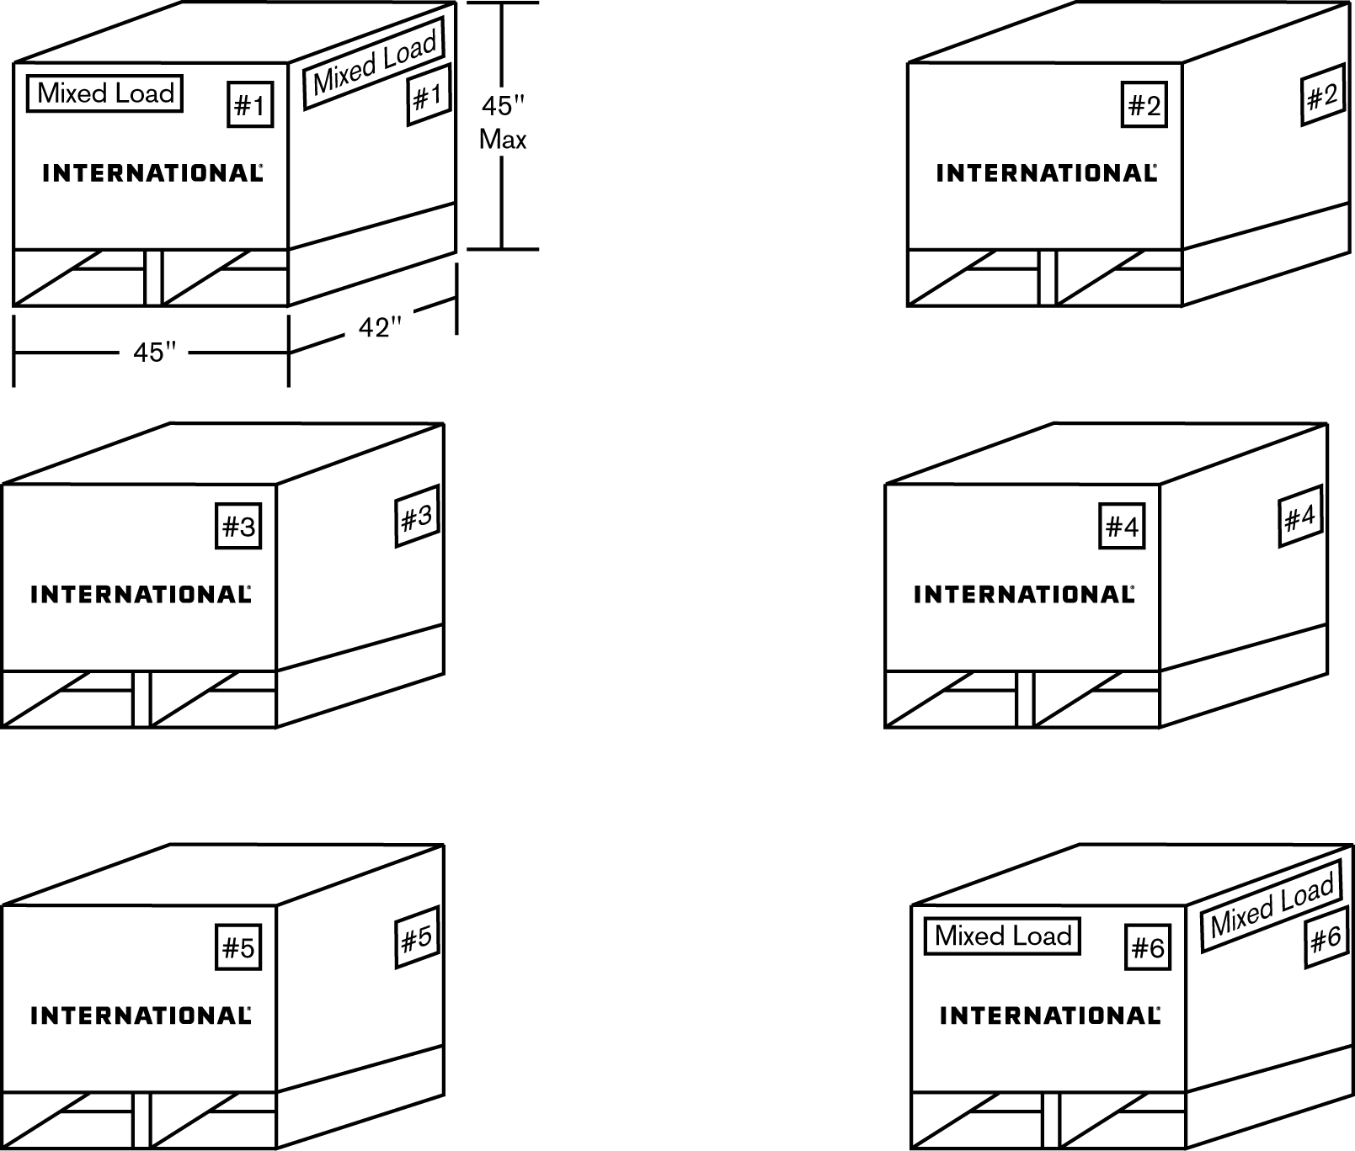

NAVISTAR

NAVISTAR

NAVISTAR

NAVISTAR

NAVISTAR

NAVISTAR

## 6.4.B Service Parts - Pallet Manifest

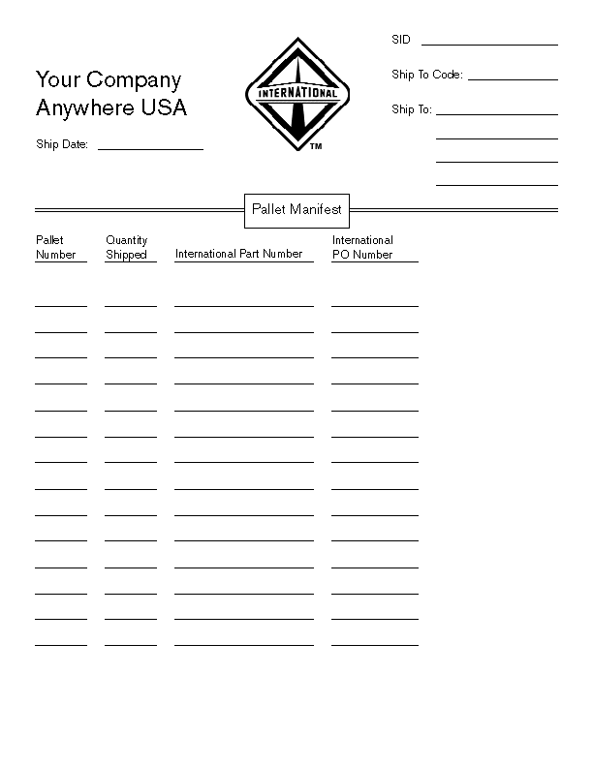

## 6.5 Transportation Regulations

Freight rates and carrier liability for damage are based on packaging specified in government regulations. The parts supplier will determine that a proposed pack meets these regulations before submitting it for Navistar Corporation approval. In addition to rules in individual publications, general rules governing shipment may be found in the following:

### 6.5.1 American Trucking Association

Attn: Traffic Department

2200 Mill Road

Alexandria, Va. 22314

703-838-1700

http://[www.trucking.com](http://www.trucking.com)

### 6.5.2 U.S. Department of Transportation

Research and Special Programs Administration

Office of Hazardous Materials Safety

400 7th St. S.W.

Washington, DC 20590

http://hazmat.dot.gov/

### 6.5.3 Transport Canada

Transport Dangerous Goods

Mail-stop: ASD

330 Sparks St.

Ottawa, Ontario, Canada KIA ON5

http://[www.tc.gc.ca](http://www.tc.gc.ca)

### 6.5.4 Secretaria de Communicaciones y Transporte

Xola Y Avenida Universidad

Cuerpo “C” Piso 1

Col. Narvarte, Del. Benito Juarez, C.P. 03028, Mexico, D.F.

http://[www.sct.gob.mx](http://www.sct.gob.mx)

## 6.6 Material Labeling

All materials must be clearly identified as to the destination (street, name, address, city, state, providence, zip or postal identification code, and country if other than U.S.) as shown in CTDR-1.

# 7.0 REFERENCES

## 7.1 Organizations and Websites

**ISPM 15 information**

[**https://www.ippc.int/IPP/En/default.jsp**](https://www.ippc.int/IPP/En/default.jsp)

Automotive Industry Action Group (AIAG)

Portions of this documentation are printed with the permission of the AIAG. Additional information can be received by contacting the AIAG at (248) 358-3570) or the AIAG Website http://[www.aiag.org](http://www.aiag.org).

### Navistar Supplier Website (ISN)

This website provides supplier information.

<https://evalue.internationaldelivers.com/supplier/>

### Department of Transportation (DOT)

Website address: http:// [www.hazmat.dot.gov](http://www.hazmat.dot.gov)

### Occupational Safety & Health Association (OSHA)

Website Address: http://www.osha.gov

### Environmental Protection Agency (EPA)

Website Address: http://www.epa.gov

### American National Standard Institute (ANSI)

Website Address: <http://www.x12.org>

**Country of Origin**

<http://ecfr.gpoaccess.gov/cgi/t/text/text-idx?sid=2cefd12d31af941581fc73e7cdea7582&c=ecfr&tpl=/ecfrbrowse/Title19/19tab_02.tpl>

**Canadian Consumer Packaging and Labelling Act**

Website Address: <http://laws.justice.gc.ca/en/C-38/36740.html>

**Quebec Packaging Regulations**

Website Address: http://www.olf.gouv.qc.ca/english/charter/

## 7.2 Referenced Documents

|  |  |  |
| --- | --- | --- |
| Request for Quotation PR-14N | Purchasing | Section 3.1 |
| AIAG B-10 Label Standard | AIAG | Section 3.2.4, 4.0, 4.3 |
| AIAG RC-1 Returnable Containers Standards | AIAG | Section 3.3.2, 3.3.5 |
| QS-9000 Standard | Purchasing | Section 3.5.2 |
| Customs Invoicing Instructions (PR-38) | Purchasing | Section 3.5.3 |
| Navistar Quality Manual (IQR) | ISN | Section 3.5.2 |
| American Trucking Assoc. RP801C | ISN | Section 3.5.5 |
| MILP15011 Type I Class A Military Specs. | ISN /ENG. TECH STDS | Section 3.5.5 (1) |
| NN-P-71C Type II Group III Military Specs. | ISN /ENG. TECH STDS | Section 3.5.5 (1) |
| ANSI AIM B-1 | ANSI.ORG | Section 4.0 |
| ANSI MH10.8.2 | ANSI.ORG | Section 4.2.2 |
| ANSI ASC X12.3.1987 Data Element Dictionary | ANSI.ORG | Section 4.2.4 |
| ANSI X3.182 \*AIAG (B10) | AIAG | Section 4.3.4 |
| DOT CFR-49 | ISN /ENG. TECH STDS | Section 4.5.4 |
| TMS 9009 Paint Specification | ISN /ENG. TECH STDS | Section 5.1.1 |
| CTDR-1 Routing Matrix | ISN/Logistics | Section 6.0 |

## 7.3 Navistar Inc. Locations

* See Navistar Ship to Code Guide located on the Navistar’s supplier website.

**APPENDIX**

##### NAVISTAR STANDARD CONTAINERS

Navistar Corporation encourages the use of Returnable Transport Items for transporting production material to its manufacturing and assembly plants. Returnable containers other than wood pallet bases must not be used for shipments to Navistar Parts Distribution Centers, or Tier 2 suppliers (see Section 3.3.1 for clarification)

###### 1.1 Introduction

Navistar Inc. encourages the use of for Returnable Transport Items transporting of production material to its manufacturing and assembly plants. These Returnable Transport items must meet company specifications for size, capacity, and material handling. Suppliers are encouraged to avail themselves of these containers, which can be obtained in minimal quantities to meet shipment needs in order to:

* Maintain product quality and cleanliness.
* Reduce disposal cost through reduction of expendable packaging materials.
* Reduce packing costs
* Permit better utilization of trailer cube during transit.

Supplier owned returnable containers are permitted providing they are compatible with plant materials handling equipment and have prior approval of the Containerization Manager.

###### 1.2 Choices of Shipping Devices/Containers

**Special** - Racks or other shipping devices are often designed for use with a specific item/commodity only. Arrangement for the use of such shipping devices must have the approval of the Containerization Manager.

The use of special shipping devices/containers, which meet applicable AIAG (Automotive Industry Action Group) standards in all aspects, is encouraged and acceptable. Special shipping containers/devices are not considered part of the Navistar container pool and their use must be arranged directly with the receiving location.

**Universal** – The following shipping containers/devices are considered universal in their application to material shipments and are maintained in limited quantities as part of the container pool. See Exhibit I for container illustrations.

|  |  |  |
| --- | --- | --- |
| **Description** | **Navistar Part Number** | **Approximate**  **Dimensions (LxWxH) Inches** |
| Pallet-Base | WOOD  1100074R3 | 42 x 42 x 5.125 |
| Separator | 1100122R1 | 42 x 42 x 2.375 |
|  |  | (39 x 39 between Cleats) |
|  | STEEL |  |
| Wire Basket | 1100124R1 | 42 x 42 x 30 |
| Wire Basket | 1100125R1 | 54 x 44 x 40 |
| Wire Basket (Hinged Sides) | 1100126R1 | 54 x 44 x 35 |
| Wire Basket (Hinged Sides) | 1100127R1 | 54 x 44 x 40 |
|  |  |  |
|  | PLASTIC |  |
| 484534 Returnable Bulk Box\* | 3449000R1 | 48 x 45 x 34 |
| Returnable Pallet-Base | 3449008R1 | 48 x 45 x 6.25 |
| 121107 Returnable Tote w/Lid Nestable | 3449010R1 | 12 x 11 x 7 |
| 323034 Returnable Bulk Box\* | 3449012R1 | 32 x 30 x 34 |
| Pallet Box\* | 3449014R1 | 32 x 30 x 25 |
| 1/24 Tote | 3449015R1 | 12 x 7 x 5 |
| 1/24 Tote | 3449016R1 | 12 x 7 x 5 |
| 1/12 Tote | 3449017R1 | 12 x 15 x 5 |
| 1/12 Tote | 3449018R1 | 12 x 15 x 5 |
| 1/12 Tote | 3449019R1 | 12 x 15 x 7 |
| 1/6Tote | 3449020R1 | 24 x 15 x 7 |
| 1/6Tote | 3449021R1 | 24 x 22 x 7 |
| 1/3Tote | 3449022R1 | 48 x 15 x 7 |
| Pallet Box\* | 3449023R1 | 48 x 45 x 25 |
| Returnable Top Cap | 3449024R1 | 45 x .220 Gauge |

\*Collapsible or Nestable

###### 1.3 Selection and Approval

Selection of the optimum container size or combination of container/shipping devices is developed thru the Navistar Right Sizing process. Approval of the Containerization Manager at the receiving location. The Supply Chain Manager can provide materials to aid in the selection and approval process as well as for making provisions for transportation of selected containers to supplier shipping point.

###### 1.4 Interior Packaging

When the nature of the product requires interior containers, wraps, or cushioning material, it will be the supplier’s responsibility to locate a source and furnish the required materials for proper interior packaging. Such materials as plastic liners may be specified to maintain container cleanliness where oils, coatings, or other undesirable materials may contaminate the containers/parts.

###### 1.5 Transportation

Navistar Returnable Trasportation Items are furnished to suppliers to assure product quality and cleanliness and compatibility with material handling systems and procedures. In addition, they provide a means of reducing costs associated with handling and disposal of expendable dunnage as well as initial packaging costs. Consequently, Navistar will provide delivery of containers to Tier 1 supplier shipping points.

Quantities of returnable containers will be limited to no more than necessary to ship 10 workdays of material including in transit. It is expected that the supplier will control the use of containers as intended by assuring the use of the Navistar furnished containers for shipments to Navistar only and only to the Navistar location which furnished the container. Periodic reconciliation of the container counts will be performed between Navistar operations and their respective supplier shipping points.

###### 1.6 Credit for Return

Supplier owned returnable containers, used only with the approval of the Containerization Manager, must be clearly identified with company name and container number in human readable as well as bar coded format if possible. Packing lists, invoices, and EDI transmissions must clearly display the corresponding Navistar container number assigned by the Supply Chain Management Group when supplier container was approved. If security deposits apply, the invoice must show the correct security deposit information to receive credit. This includes container part number and quantity shipped.

###### 1.7 Repair and Cleanliness

Only containers/shipping devices which are clean and in good repair will be provided to suppliers. If suppliers receive containers not in satisfactory condition, the Navistar location from which the containers were provided must be advised immediately for corrective action. Suppliers are expected to maintain the condition and cleanliness of containers. Protective liners will be specified where necessary to assure contents are maintained clean and well protected while enroute and that the container can be reused with minimum cleaning effort.

###### 1.8 Standard Shipping Bundles

To facilitate loading and shipping, empty returnable containers are shipped in standard bundle quantities.

|  |  |  |  |
| --- | --- | --- | --- |
| **Component** | **Units/Bundle** | | **Base Pallet** |
| Pallet Base (Wood & Plastic) | 8 + | | 1 |
| Separators | 18 + | | 1 |
|  |  | |  |
|  |  | |  |
|  |  | | |
| Modular Containers |
| 1/16 Tote 3449010R1 | 16 | 1\* | |
| 1/24 Tote 3449015R1 | 24 | 1\* | |
| 120708 Tote 3448016R1 | 24 | 1\* | |
| 1/12Tote 3449017R1 | 24 | 1\* | |
| 1/12 Tote 3449018R1 | 12 | 1\* | |
| 151207 Tote 3449019R1 | 12 | 1\* | |
| 241507 Tote 3449020 R1 | 6 | 1\* | |
| 1/6Tote 3449021R1 | 6 | 1\* | |
| 481507 Tote 3449022R1 | 3 | 1\* | |

\* Per every three (3) or less bundles

###### 1.9 Shipping Devices

1.9.1 Wood Shipping Devices

|  |  |
| --- | --- |
| Pallet Base | Separator |
| PALLET | SEPARATOR |

1.9.2 Steel Containers

**(Wire Baskets)**



1.9.3 Plastic Containers

|  |  |
| --- | --- |
| Pallet Box | Modular Box with Lid |
| PlasticBox | Totes |

##### 2.0 SHIPPING ABBREVIATIONS, TERMS AND DATA IDENTIFIERS

###### 2.1 Abbreviations

* See latest edition of ANSI X-12 Standards Guide for unit measurement (code data element #355).
* See the AIAG websites for additional information (See Section 7.1 Organizations and Websites).

###### 2.2 Definition of Terms

**Common Item Pack**

A pack, which contains all, like items, i.e., same part/item numbers.

**Item**

A single part or material purchased, manufactured, and/or distributed.

**Label**

A card, strip of paper, etc., marked and attached to an object to indicate its nature, contents, ownership, destination, etc.

**Master Label**

A label used to identify and summarize the total contents of a multiple pack.

**Mixed Item Pack**

A pack containing items with different part numbers.

**Mixed Load Label**

A label used to designate mixed item, shipping packs.

**Multiple Pack**

A pack containing smaller packages (subpacks) of items.

**Non-Standard Quantity Pack**

A pack, which contains variable quantities of like items.

**Pack, Package, or Load**

A unit which provides protection and containment of items plus ease of handling by manual or mechanical means. Examples of containers or packs which normally are disposable include bags, cartons, cartons on pallets, and pallet boxes. Examples of containers or packs which are returnable include bins (wire mesh or solid), racks (plain or with special dunnage), racks with wire mesh sides and ends, tubs, and drums.

**Placard**

A base label which is attached to a plastic container, onto which shipping labels are attached (this allows for easy removal).

**Shipping Identification Label**

A label used to identify the contents of a shipping pack.

**Shipping Pack**

A pack used for shipping items from one manufacturing plant to another and can be any of the packs described above.

**Standard Quantity Pack**

A pack which always contains the same quantity of like items.

**Sub-packs**

One of the smaller packs (which may be a standard quantity or non-standard quantity pack) that comprise a larger multiple pack.

**Tag**

A label that is hung from an object, usually with a wire placed through a reinforced eyelet in the label/tag.

###### 2.3 Bar Code Identifiers or ABR Identifiers

The Following data identifier codes have been assigned by the AIAG:

**P** – Part Number or ABR Identifier

**C** – Continuation of long part numbers if required.

**Q** – Quantity

**V** – Supplier Number

**K** – Purchase Order Number

**1B** – Container Identification

**D** - Date

**S** – Serial Number of an engine or other entity

**2S** – Shipment Identification Number (Data Element 396)

**3S** – Full Pallet Serial Number

**4S** – Master Label Serial Number

**5S** – Mixed Load Serial Number

**4L** – Country of Origin

For other data identifiers, see AIAG’s Standard for Bar Coded Data Identifiers as shown in AIAG

B –10 Trading Partner Labels Publications. Additional information can be obtained by contacting AIAG.

###### 2.4 Recommended Data Order

See Advanced Ship Notice: EDI – 856 Business Process Guide for each respective Business Unit.

See the Navistar Supplier Website for more information (See Section 7.1 Organizations and Websites for more information).

##### 3.0 SHIPPING/ RETAIL LABEL EXAMPLES

###### Example 3.1 – Shipping Label

|  |
| --- |
| **Ship-To Information** |
| Block Title = To |
| Data = Shipping Address of the destination XYZ Plant |
|  |
|  |

|  |
| --- |
| Supplier Information |
| Block Title = From |
| Data = Name and address of supplier |

|  |  |
| --- | --- |
| FROM:  ABCDEFGHIJKLMNOPQRSTUVWXYZ  ABCDEFGHIJKLMNOPQRSTUVWXYZ  ABCDEFGHIJKLMNOPQRSTUVWXYZ | TO:  ABCDEFGHIJKLMNOPQRSTUVWXYZ  ABCDEFGHIJKLMNOPQRSTUVWXYZ  ABCDEFGHIJKLMNOPQRSTUVWXYZ |
| PART NO. **1234567890123456**  CUST (P) 1234567890123456 | |
| QUANTITY (Q) **1234567890123456**  1234567890123456 | |
| SPLR ID **123456**  CUST ASSGN (V) 1234566 | |
| PKG ID-UNIT **123456789**  (3S) 123456789 | |

|  |
| --- |
| Part Number |
| Block Title = Part #  Cust (P) |
| Data = the Part # as assigned by XYZ Co. |
| Data Identifier (DI) = P |
| Maximum Data: =Part Number Data Chars +1 Char (DI) |

|  |
| --- |
| Quantity of Pieces |
| Block Title = Quantity (Q) |
| Data = The number of pieces in this container |
| Data Identifier (DI) = Q |
| Maximum Data: = Quantity Chars + 1 Char (DI) |
| Note: Unit of measure is assumed as each. Any other unit of measure must appear in human readable text only, next to the interpretation of the bar code |

|  |
| --- |
| Supplier ID Number |
| Block Title = SPLR ID  CUST ASGN (V) |
| Data = The vendor identification code assigned to your location by XYZ Co. |
| Data Identifier (DI) -= V |
| Maximum Data: = Vendor Code Chars + 1 Char (DI) |

|  |
| --- |
| Container Label Serial Number |
| Block Title = PKG ID – UNIT (3S) |
| Data = A supplier-assigned control number, unique for this container, not to be repeated within 365 days |
| Data Identifier (DI) = 3S |
| Maximum Data: = Package Id Unit Chars + 2 Chars (DI) |

\* NOTE: LABEL IS NOT TO SCALE

**Label Use**: This label should be used to identify the contents of an individual container of a single part number for a shipment. (See AIAG B-10 Trading Partner Labels Implementation Guideline for more information.)

3.0 SHIPPING/ RETAIL LABEL EXAMPLES (Continued)

###### Example 3.2 – Master Label

\* NOTE: LABELS ARE NOT TO SCALE

**Label Use**: This label should be used to identify the total contents of a multiple single pack load of the same part number for a shipment. (See AIAG B-10 Trading Partner Labels Implementation Guideline for more information.)

|  |  |
| --- | --- |
| FROM:  ABCDEFGHIJKLMNOPQRSTUVWXYZ  ABCDEFGHIJKLMNOPQRSTUVWXYZ  ABCDEFGHIJKLMNOPQRSTUVWXYZ | TO:  ABCDEFGHIJKLMNOPQRSTUVWXYZ  ABCDEFGHIJKLMNOPQRSTUVWXYZ  ABCDEFGHIJKLMNOPQRSTUVWXYZ |
| **MASTER LABEL** | |
| PART NO. **1234567890123456**  CUST (P) 1234567891012356 | |
| QUANTITY (Q) **123456**  123456 | |
| SPLR ID **1234567890123456**  CUST ASSGN (V) 1234567890123456 | |
| PKG ID-MASTER **123456789**  (4S) 123456789 | |

3.0 SHIPPING/ RETAIL LABEL EXAMPLES (Continued)

###### Example 3.3 – Mixed Load

|  |  |  |  |
| --- | --- | --- | --- |
| FROM:  ABCDEFGHIJKLMNOPQRSTUVWXYZ  ABCDEFGHIJKLMNOPQRSTUVWXYZ  ABCDEFGHIJKLMNOPQRSTUVWXYZ | | | TO:  **ABCDEFGHIJKLMNOPQRSTUVWXYZ**  **ABCDEFGHIJKLMNOPQRSTUVWXYZ**  **ABCDEFGHIJKLMNOPQRSTUVWXYZ** |
| MIXED LOAD | | | |
| SPLRID  CUST ASGN (V) | **1234567890123456** | | |
|       1234566789012326565465 | | | |
| PKGID – MIXED  (5S) | | **123456789** | |
|       1234567891061294 | | | |

***\* NOTE: LABEL IS NOT TO SCALE***

**Label Use**: This label should be used to identify a load of multiple single packs of different part numbers for a shipment. (See AIAG B-10 Trading Partner Labels Implementation Guideline for more information.)

###### Example 3.4 – Service Retail Label (RP801C)

###### 

***\* NOTE: LABEL IS TO SCALE***

**Label Use**: A Retail label must be used to identify individual parts for Service. (See the Navistar Supplier Website under the Service Parts Page for the Retail Bar Coding Specifications). Label size and branding will be established by Packaging Specification Team and Parts Product Manager. For a complete detailed list of packaging specifications request a retail packaging report (See the Navistar Supplier website under the Service Parts’ page for the retail packaging request form).

###### Example 3.5 - Truck –Shipping Label -Special Data Area:

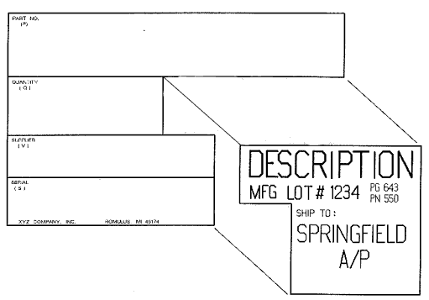

STANDARD SHIPPING LABEL SPECIAL DATA AREA “FREE SPACE”

##### 4.0 QUICK RECEIVE LABEL

The purpose of the customer Quick Receive Label is to allow mechanical match of a supplier’s incoming shipment to the information on the supplier’s EDI ASN (856). To accomplish this, the information on the Quick Receive Label **MUST** uniquely identify the shipment for the customer. A quick receive label must be affixed to the pack list.

Suppliers must comply with the Navistar Inc. Quick Receive Guideline, which may be found on the Navistar Supplier website.

###### Example 4.1 – Quick Receive Label

**\* NOTE: LABEL IS NOT TO SCALE**

|  |
| --- |
| Quick Receive |
| (2S) ASN SHIPMENT ID |
| 1215484512121545152121 |
| 109145 |
|  |
| (13V) DUNS VENDOR ID |
| 1236524545121154512121 |
| 48129X1 |
|  |

##### 5.0 ABR LABEL EXAMPLES

###### Example 5.1. - ABR Container Label:

|  |
| --- |
| Line #1 Lineset #1234  1234 |
| Part No. ABR ASM  (P) |
| Supplier: 1111122 Job #123456  (V) 1111122  123456  |
| Serial No: 12345605112000  (S) 12345605120000 |
| Labor Group 1234  (G) 1234 |

**\* NOTE: LABEL IS NOT TO SCALE**

5.0 ABR LABEL EXAMPLES (Continued)

###### Example 5.2. - ABR Part Label:

\* NOTE: LABEL IS NOT TO SCALE

|  |  |
| --- | --- |
| PART # ABR ASM | JOB: 123456 |
| LABOR GROUP: 56 | 123456 |
| SUPPLIER ID: 125 | LINESET: 1-1004 |
| SERIAL: ATAY123456  Ata123456 | |

**Size:** 4” wide by 1.5” tall

**Data to be listed**

* JOB Number - 6 numeric.
* Labor Group - 4 numeric
* Part # - ABR ASM - designates ABR Module Assembly.
* Supplier ID
* Serial # Identifier
* Lineset Number

All data will be listed in human readable format.

The Job Number and Serial # Identifier will also be encoded as a barcode.

**Lineset number format**

* The lineset number will contain both the line and lineset number
* The line and lineset number will seperated by a dash (-).

**Serial # Identifier format**

* The first three characters will be the ATA Identifier ( see table below)
* The Fourth character will be a separator character. This will be the letter Y.
* The last 6-9 characters will be the Supplier Serial # of the Module.

**Barcode Information**

* Code 3 of 9
* Bottom barcode will contain the Serial # Identifier
* Top barcode will contain the job number.

5.0 ABR LABEL EXAMPLES (Continued)

###### Example 5.3 - ABR Container Label:

**ATA Module code**

* 002 for Cab
* 030 for Electrical

**Lineset Container Label:**

|  |
| --- |
| LINE #1 LINESET # **1234**  (1W) 123454 |
| PART NO. **1234567C91**  **(**P) 1234567c91 |
| SUPPLIER: **1111122** JOB # **123456**  (V) 1111122       (W) 123456     |
| SERIAL NO. **12345605112000**  (S)        1234560512000 |
| LABOR GROUP: **1234**  (G) 1234 |

***\* NOTE: LABEL IS NOT TO SCALE***

##### 6.0 LABEL LOCATIONS ON VARIOUS SHIPPING PACKS

|  |  |
| --- | --- |
| Box | 6.1 Exhibit - BOX OR CARTON Identical labels should be located on two adjacent sides. (Wrap around labels acceptable). The upper edges of the labels should be as high as possible up to 20 inches from the bottom of carton. |
|  | 6.2 Exhibit - CARTONS ON PALLET Each carton should be individually labeled as described above . One master label may be used as described in Section 4.5.1 or one mixed load label as described in 4.5.2. |
| Cylinder | 6.3 Exhibit - DRUMS, BARRELS, OR CYLINDRICAL CONTAINERS Identical labels should be located on the top and near the center of the side. |
| Bale | 6.4 Exhibit – BALES Identical labels should be located at the upper corner of an end and the adjacent side (wrap around label acceptable). |

|  |  |
| --- | --- |
| Basket | 6.5 Exhibit - BASKET, WIRE MESH CONTAINER Identical labels should be located on two adjacent sides |
| Metal_Bin | 6.6 Exhibit - METAL BIN OR TUB Tag one visible piece near top or use a label holder. |
| PalletBox | 6.7 Exhibit - PALLET BOX Identical labels should be located on two adjacent sides. (Wrap around label acceptable). |
| TelScop_Box | 6.8 Exhibit - TELESCOPIC OR SET-UP CONTAINERS Identical labels should be located on two adjacent sides of the outer box. Some applications may also require identification of the inner box. |

|  |  |
| --- | --- |
| **Bundle** | 6.9 Exhibit - BUNDLE Identical labels should be located at each end. |
| **Bag** | 6.10 Exhibit – BAG Place on label at the center of face. |
| **Roll** | 6.11 Exhibit – ROLL Hang one tag 2.0 in. (51 mm) from end of the material.  **NOTE:**  Put pallets under all the exhibits above. |
| **Rack** | 6.12 Exhibit – RACK Tag one visible piece near top or use a label holder Line-Set Racks Must have a placard on rack. |

##### 7.0 CTDR – ROUTING & SHIPPING INSTRUCTIONS

###### 7.1 See Navistar Inc. Routing Instructions (CTDR-1)

See Navistar Inc. Routing Instructions (CTDR-1) on Navistar’s Supplier website (See Section 7.1 Organizations and Websites for more information).

###### 7.2 Bill of Lading Requirements, Domestic

While it is not our intent to provide line-by-line instructions relative to the preparation of a B/L (Bill of Lading), the following significant items must be emphasized:

7.2.1 Supplier Number

All Navistar purchase orders and shipping releases contain an alphanumeric code identifying the supplier. Please include this number in the “consignee” address when preparing your B/L. (Bill of Lading)

7.2.2 Classification

The material shipped must be completely and accurately described by use of the appropriate NMFC item and description.

7.2.3 Third Party Billing

When Navistar orders material with instructions to ship to a third party (i.e., heat treating, etc.) and Navistar is responsible for the freight charges, your B/L (Bill of Lading) must clearly show which Navistar facility is to pay the freight charge.

(i.e.) Navistar Purchases part number 123456R1 to be shipped to XYZ Heat Treat on behalf of a Navistar facility, and freight terms are F.O.B shippers’ plant for the account of Navistar. Your B/L (Bill of Lading) must read:

Consign to: Navistar Inc.

(Name of appropriate Navistar Facility)

c/o XYZ Heat Treating

100 South Street

Fort Wayne, IN 46808

Please use the following notation in the Body of the Bill of Lading:

Send Freight Bill with a Copy of the delivery Receipt to:

Traffic Supervisor

Navistar Inc.

(Name appropriate Navistar Facility)

Street Address

City, State, Zip

7.2.4 Truckload Shipment

Supplier is required to provide a minimum of three (3) copies of the Bill of Lading to the carrier.

###### 7.3 BILL OF LADING REQUIREMENTS, CONSIGNMENTS TO CONSOLIDATION CENTERS

7.3.1 U.S. Destinations Only

All shipments scheduled to move to a single freight consolidation location on one day must be covered by a single B/L (Bill of Lading) regardless of the number of “ultimate” destinations included in the total consignment. Shipments are to be consigned to Navistar Inc. in care of the applicable consolidator indicated on the specific routing instructions.

###### 7.4 BILL OF LADING REQUIREMENTS – DIRECT SHIPMENTS

All shipments scheduled to be shipped in one day to one destination must be combined on one B/L.(Bill of Lading).

###### 7.5 DOCUMENTATION REQUIREMENTS - IMPORT/EXPORT

All imports and exports must comply with the Navistar Inc. Customs Invoicing Instructions for Suppliers Shipping between Canada and the United States and from Canada or the United States to Mexico (Form PR-38).

###### 7.6 DESTINATION LABELING

All pieces in a shipment (i.e., pallets, cartons, drums, bags, pieces, etc.) must be clearly tagged/labeled showing their specific “ultimate” destination. If a shipment is routed via a consolidator, the consolidator is not to be considered the “ultimate” destination. The “ultimate” destination is the Navistar facility, i.e., Springfield Assembly Plant or Burlington Parts Distribution Center. If these procedures are not adhered to, it is virtually impossible for the consolidator to re-ship the material to the correct “ultimate” destination without a lot of excessive effort and delays. Use of AIAG Standard shipping labels as shown in Section 3.1 is not acceptable by itself as a destination label.

###### 7.7 SAMPLE UNIFORM STRAIGHT B/L \*

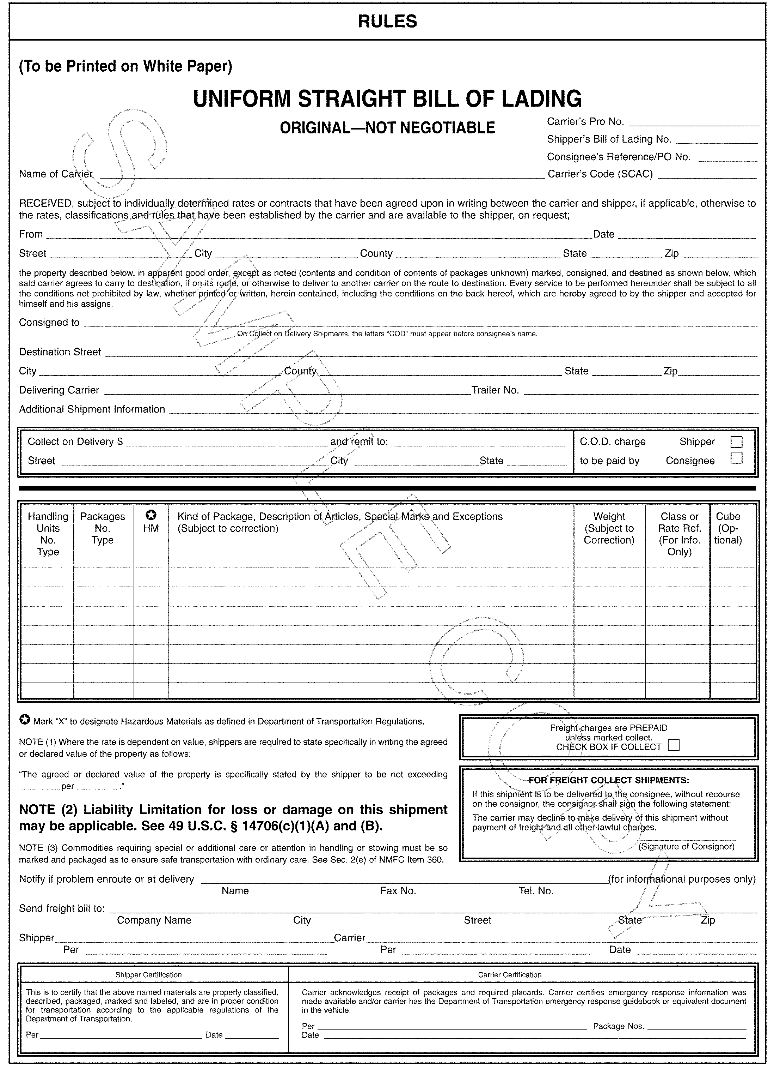

### Sample copy – Contact American Trucking Association to get latest form.

###### 7.8 SAMPLE UNIFORM STRAIGHT B/L SHORT FORM \*

**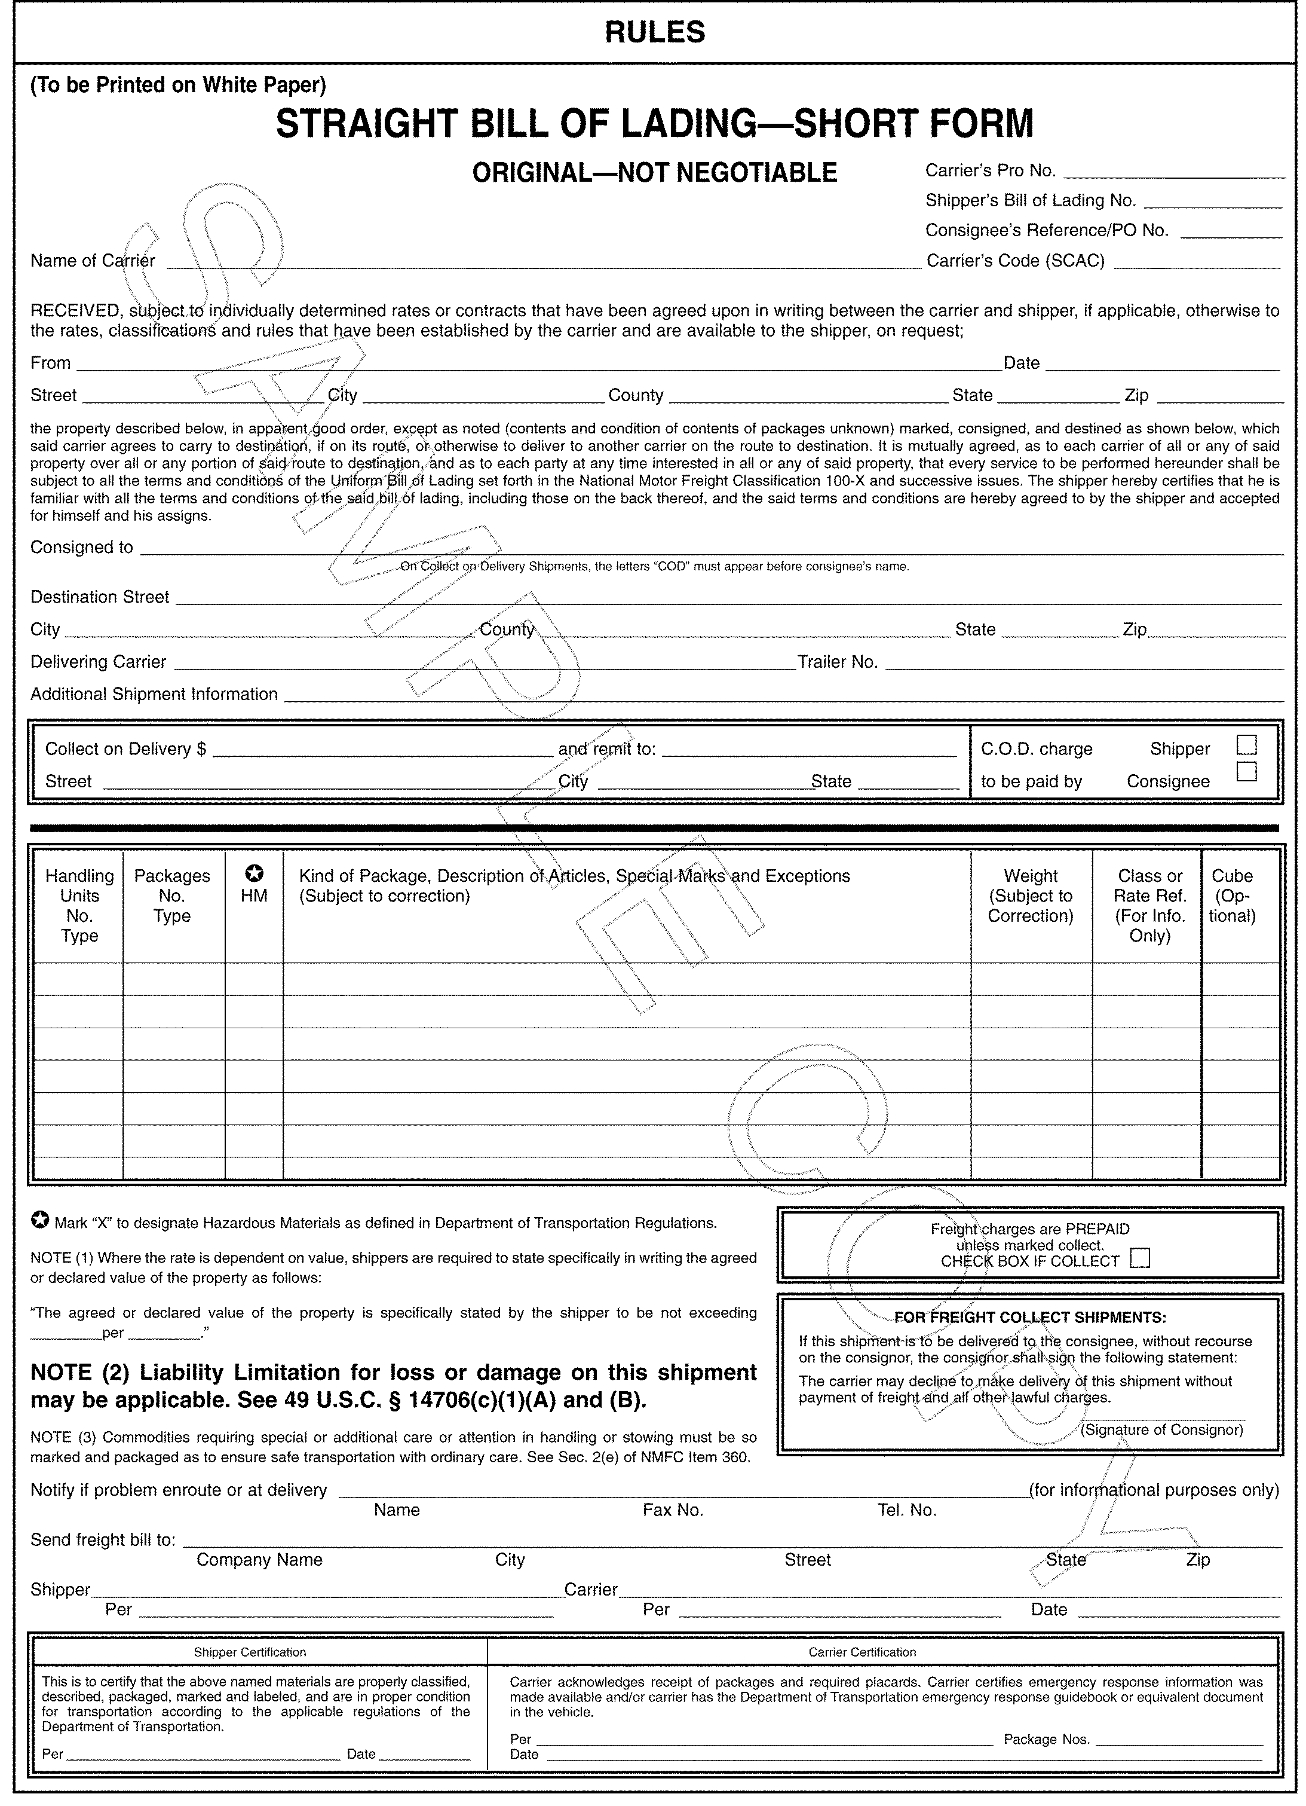**

### \* Sample copy – Contact American Trucking Association to get latest form.

##### 8.0 VOLATILE CORROSION INHIBITORS

###### 8.1 DEFINITION

Volatile corrosion inhibitors (VCI) are any of a group of chemicals that involve vapors, which protect metal surfaces from corrosive substances in the atmosphere without removal of these substances. The exact nature of the inhabitation is not clearly understood. It is thought that the vapors hydrolyze in the presence of water and the products of hydrolysis prevent corrosion. The main group and nitrites have long been used in water to prevent corrosion. The chemical must be sufficiently volatile at ordinary temperature to provide enough vapors to protect as well as to provide the vapors quickly and over a long period of time.

###### 8.2 INHIBITOR PROPERTIES

The vapors are heavier than air and tend to collect at the lower part of the package. Since VCI chemicals are affected by heat, acid, and water, VCI packs should be stored away from heaters, acid atmospheres, water drips, sunlight, and strong air movement. New VCI stock should be stored in its original wraps with the oldest stocks used first. Acid decomposition of VCI is considered again in the section on cleaning.

###### 8.3 CARRIER

The best packaging utilization of VCI chemical is by application to wrapping papers (called carriers) by impregnation or coating. These treated carriers are commercially available in the forms of flat and creped kraft rolls and sheets, barrier papers or shrouds, bags, envelopes, box-boards, transparent wraps, and tubes.

Tests have shown that the carrier over wrap gives better protection for larger packs than VCI crystals, sprays, or VCI on small amounts of paper. Further, an over wrap prevents the rust susceptible part from touching the non-neutral container and the carrier over wrap prevents inhibitor vapor from concentrating on the bottom as in the case of crystals.

###### 8.4 TOXICITY

Rats feeding on one chemical showed toxicity of sodium nitrite; a common food additive. Another supplier chemical is a blend with sodium nitrite. There is no record of health hazard in our years of use, but as a precaution, personnel should be advised to wash hands before eating. Any odor complaint may be treated by ventilation. Individuals showing allergies should not handle VCI materials.

###### 8.5 APPLICATION

The common commercial practice of 12-inch maximum distance from treated paper to part is acceptable as a rule of thumb. The treated carrier should be the innermost wrap in the carton. In order to maintain a 12-inch maximum distance in a larger container, it will frequently be necessary to interleave VCI sheets among parts in a large pack. The effectiveness of a VCI package is dependent on its ability to confine the vapors in the package.

An oil film on ferrous metal parts was found to increase VCI package life. A fingerprint neutralizer solution that leaves an oil film is recommended and may be used as a cleaner for very light dirt.

Parts removed from a VCI pack are unprotected and should be used soon or returned to the VCI protection. VCI protected parts may be used without further cleaning unless there is objectionable paper dust present.

###### 8.6 CLEANING

The amount of protection given by the VCI depends upon the degree of cleanliness. Fingerprints on ferrous metals will rust even though protected with VCI. Emulsion cleaners and petroleum solvents are good cleaners. Alkaline cleaners are good if rinsed. Vapor degreasing with chlorinated solvents is risky because the residue may decompose to an acid product that may not only cause corrosion but also decomposes the VCI chemical. Temporary corrosion preventives and neutral machine oils on clean parts need not be removed before VCI packaging.

###### 8.7 EFFECT ON NON-FERROUS MATERIALS

VCI protection is intended for ferrous metals and aluminum metals. Other VCI chemicals formulated to preserve silver or copper are not considered here. In tests, there has been no noticeable effect of the vapor on aluminum, brass, or galvanized steel, but tests showed VCI adversely affected cadmium plate and copper.

###### 8.8 PRACTICE CORRECT PROCEDURES WITH VCI

|  |  |
| --- | --- |
| **DO** | **DON’T** |
| Use mainly for ferrous metals and aluminum | Don’t waste VCI liners on boxes containing wrapped parts |
| Clean parts before VCI packaging | Don’t use VCI on parts cleaned in a vapor degreaser |
| Make VCI the innermost wrap.  Close packages tightly | Do not expect protection while the part is removed from its VCI wrap. |
| Place VCI paper close to metal | Don’t use new stocks before old |
| Store VCI paper in its original closed wrap, away from heat, moisture, and wind | Don’t put wrong side toward the metal  Don’t use VCI with cadmium plate or copper/ |

##### APPENDIX FOR NAVISTAR, INC. ENGINE GROUP SUPPLIER GUIDE

###### ELECTRONIC DATA (Element 1.0)

1.1 Electronic Data Interchange (EDI)

Electronic Data Interchange (EDI) is the electronic exchange of routine business

transactions using standard data formats and integrating them into software applications and business processes. All suppliers are required to comply with Navistar’s EDI

requirements within sixty days of notification Navistar facilities utilize several EDI transactions to facilitate communication with its suppliers. These transactions utilize the American National Standards Institute’s (ANSI) X-12 Standard and

are supported by the Automotive Industry Action Group’s (AIAG) Automotive Industry

Implementation Guides. These *“Implementation Guides”* for applicable transactions can be

found at http://evalue.internationaldelivers.com/supplier/ under the “Other

documentation/EDI” tabs. For more information on the American National Standards

Institute (ANSI) please visit www.ansi.com; or, for more information on the Automotive

Industry Action Group please visit www.aiag.com.

Navistar Corporate ISA ID 01:781 495 650

Navistar Big Bore Diesels, LLC GSid 784 218 583 Plant Code 029

Navistar Diesel of Alabama, LLC GSid 115 117 926 Plant Code 040

Melrose Park Plant GSid 005 245 238 Plant Code 083

The Engine Group utilizes the following EDI transactions sets:

1.1.1 820 – Payment Order/Remittance Advice

1.1.2 824 – Application Advice

1.1.3 830 – Planning Schedule with Release Capability

1.1.4 846 – Inventory Inquiry/Advice

1.1.5 856 – Ship Notice/Manifest (Advanced Shipping Notice – ASN)

1.1.6 997 – Functional Acknowledgement

1.2 Electronic Receipts Settlement (ERS)

Electronic Receipts Settlement (ERS) is a business process between trading partners that

conducts commerce without invoices. For the Engine Group, ERS invoices are based on the

EDI 846 transmitted to the suppliers as Supplier Managed Inventory (SMI) material is

transferred from the Logistics Provider to the using Plant. The EDI 846 will match the

EDI 820 that is transmitted when the check is issued. Both the EDI 846 and EDI 820 will

reference the ASN created by the Logistics Provider on your behalf. You may access the

*Evaluated Receipt Settlement (ERS) Invoicing Procedures* at

http://evalue.internationaldelivers.com/supplier/ and clicking on the “Other

documentation/Evaluated Receipt Settlement (ERS)” tabs.

###### LOGISTICS (Element 2.0)

2.1 Supplier Managed Inventory (SMI)

Supplier Managed Inventory (SMI) is the ownership and management, by the supplier, of

established inventory levels at a designated facility. All Engine Group suppliers are required to

participate in the SMI program. All non-NAFTA supplying locations are required to maintain an

adequate supply of material within the United States, at their expense, which will then be

shipped to their respective Logistics Provider(s) in order to maintain their established

minimum/maximum inventory levels. Non-NAFTA suppliers should contact the Purchasing

and Logistics group to discuss their specific SMI terms as a global shipper.

2.1.1 Process

• EDI 830 is transmitted as a forecasting tool, not an authorization to ship.

• Each Plant’s Material’s Group will provide the applicable minimum and

maximum levels dependent upon volumes, geographic location, and standard

packs.

• Supplier ships all material to each Engine Plant’s Logistics Provider in order to maintain the established minimum and maximum inventory levels. It is the

responsibility of the Supplier to notify the using Plant’s Materials personnel if

unusual circumstances will drive inventory levels below the established

minimums, as well as it is the Supplier’s responsibility to expedite in this event.

The Logistics Provider for each Plant is:

o Navistar Big Bore Diesels, LLC:

Perez Services Incorporated

255 Short Pike

Huntsville, AL 35824

o Navistar Diesel of Alabama, LLC:

Perez Services Incorporated

255 Short Pike

Huntsville, AL 35824

o Navistar, Melrose Park Plant:

ODW Contract Services

5300 Proviso Drive

Melrose Park, IL 60160

• The supplier must transmit an EDI 856 (ASN) to the using Engine Plant at time

of shipment. This ASN will be used to facilitate receipt into the Logistics

Provider facility and will ***not*** be used in the payment process. Once the ASN is

used to facilitate the receipt into SMI, it will serve no further function in the process.

Additionally a quick receive label must be affixed to the packing slip

attached to the shipment.

• Once received by the Logistics Provider, a secured website (2.1.2) will be

updated to reflect the receipt and on-hand quantities.

• Engine Plant requirements are generated and communicated to the Logistics

Provider.

• Logistics Provider will prepare material for shipment to Engine Plant, create an

ASN on the behalf of the supplier and the website will be updated to reflect the

shipment and on-hand quantities.

• Engine Plant receives material and ASN, at which time ***ownership changes*** from supplier to Navistar.

• Navistar transmits an EDI 846 and the ERS

process begins.

2.1.2 Logistics Providers and Website Addresses

Agreements will be in place between each supplier and their Logistics Provider(s) to

cover roles and responsibilities while a supplier’s material is in the care and custody of

a third party. Blank agreements can be found in a .pdf format on the websites below.

• Navistar Big Bore Diesels, LLC utilizes ***Perez Services Incorporated***.

o www.webperez2.com

• Navistar Diesel of Alabama, LLC utilizes ***Perez Services Incorporated***.

o www.webperez2.com

• Navistar, Melrose Park Plant utilizes ***ODW Contract Services***.

o www.melrosepark.odwcs.com (Scoreboard/Access My Account)

***NOTE: It is required (see “Supplier Performance – Element 6.0”) that suppliers check the respective website(s) for each Navistar Engine Plant that they supply, at least once each operating day.***

###### TRANSPORTATION (Element 3.0)

3.1 Centralized Routes

The Engine Group makes every attempt to assign each supplier to a truckload route where

feasible. A routeis a structured method of delivery; based on geographic regions, established frequencies, designated carriers and assigned window times. A route may consist of multiple suppliers on a single trip. Each supplier will be notified individually of their carrier, frequency

and specific schedules for pick-ups and delivery. Suppliers are required to adhere to their

assigned schedule.

3.1.1 Cross-Docking

In order to maximize transportation efficiencies, the Engine Group may utilize cross-

docking where feasible. Cross-docking is a process of delivery to one location, consolidation, and reshipment of goods to their ultimate destination. All cross-docking activities will occur at one of the Engine Group Logistics Providers, and will be loaded

for its subsequent destination the same day it is received. Please note the

requirements below.

3.1.1.1 Requirements

• Separate EDI 856’s (ASN’s) must be transmitted for each using Plant’s shipment.

• Separate Bills of Lading must be generated for each using Plant’s

shipment.

o ***Note: If shipping via LTL, suppliers are also required to***

***create a Master Bill of Lading. A Master Bill of Lading must have a combined skid count and combined total weight for***

***each separate Bill of Lading and must be clearly marked as “Master Bill of Lading.” Each separate Bill of Lading must***

***be attached behind the Master Bill of Lading. The “ship to”***

***on the Master Bill of Lading must read: “Navistar c/o (Logistics Provider’s name and address where the material will be cross-docked)”***

• Each skid must be clearly identified (i.e. 8-1/2” x 11” sheet of paper) with name of the using Plant. This identification must be facing a

loader/unloader, and must be visible from an unloading device (i.e.

forklift, pallet jack, etc.).

• If it becomes necessary to expedite cross-dock material, shipments

***must*** be shipped directly to the Logistics Provider for the using Engine

Plant.

3.2 Shipments not on Centralized Routes

All shipments will be made in accordance with the instructions set forth in the

*“ LTL & PARCEL ROUTING INSTRUCTIONS”*  *(“Transportation Routing*

*Matrix”)* that can be found online at http://evalue.internationaldelivers.com/supplier/ under the

“Other documentation/Logistics” tabs. You will need to enter your email address to login.

3.2.1 Less-than-load (LTL)

In general, less-than-load (LTL) shipments weigh less than 15,000 pounds, or fill less than 60% of a carrier’s trailer, or utilize less than 14 linear feet of a trailer.

3.2.2 Parcel

According to the *“LTL & PARCEL ROUTING INSTRUCTIONS”*  *(“Transportation Routing Matrix”)*, shipments under 200 pounds and less than eight containers should be shipped via UPS Ground, Collect billing (UPS account numbers

are available on the matrix).

3.3 Expedited

An expedite is a shipment requiring special service, which may require delivery sooner than

the agreed standard. All associated costs for an expedite will be the responsibility of the party

at-fault. If an expedite becomes necessary, the supplier is required to communicate the

following information to the using Plant at time of shipment: shipment contents; detailed pick-

up and delivery information; carrier name, contact name and phone number.

***NOTE: Failure to comply with these instructions will result in chargebacks through material***

***invoice reduction. A deviation from a specific routing may be authorized by Navistar’s***

***local operations personnel on an emergency shipment-by-shipment basis. In such cases, you should clearly record the name of the authorizing individual on the bill of lading.***

###### PACKAGING AND LABELING (Element 4.0)

4.1 Packaging

In adherence to ISO 14001 Environmental Standards, the Engine Group makes all attempts to eliminate waste by utilizing returnable containers and packaging. ALL production

material MUST be delivered in returnable packaging; any exceptions must be pre-approved, in writing, by the using Plant.

4.1.1 Packaging Specifications

You can find the packaging specifications (*D-13 Packaging Specifications*) for

Navistar at

http://evalue.internationaldelivers.com/supplier/ following the “*Logistics*” tabs. Packaging specifications specific to the Engine Group are located in the Appendix of this document.

4.1.2 Supplier’s Responsibility

* Suppliers must contact the Engine Group Packaging Specialist before beginning the packaging design phase.
* Suppliers must complete a Container Specification Form for all Tier 1 production intent parts, and all approvals must be in place prior to containers/packaging being procured. This requirement applies to both returnable packaging and expendable alternatives if applicable.
  + - Navistar has the option, if necessary, of approving or rejecting a supplier’s selection of packaging materials and sources.
    - The determination of the type of standardized modular and customized returnable container and associated internal and/or external dunnage will result from the collaborative agreement between the supplier and Navistar.
    - The supplier must ensure that the parts and all packaged shipments, no matter the style of packaging, are received in acceptable (damage free) condition, are efficiently and economically packaged for the method of transportation, type of handling planned for the final destination and its intended point of use.
    - Suppliers will ultimately be responsible for the design and testing of packaging.
    - Suppliers are required to de-label and clean all packaging. It is the supplier’s responsibility to ensure that the container cleanliness should be such that it does not affect part integrity, it is maintained at all times, and there is no impact on the part. Specific part cleanliness specifications should be discussed with your Supplier Quality Engineer (SQE).
    - All features/surfaces considered critical to the quality of the operation of the part (e.g. machined surface, bore, etc) must be protected from damage and/or moisture, contamination, or other debris as required by Navistar Engineering and Supplier Quality.
    - Returnable packaging is expected to be designed and in use by the Pre-Production Approval Process (PPAP) phase.

4.1.3 Container Standards

4.1.3.1 General Specifications

• All containers must conform to applicable AIAG standards, including a

48” x 45” x 34” footprint.

• All pallet loads are to be secured with a seatbelt and buckle system (or approved alternative containment methods) with proper tensioning to secure the unit load. Over tightening will cause a deflection in the pallet, top cap and/or containers and this condition is unacceptable. Insufficient tension will allow easy movement or shifting of packaging components and this condition is also unacceptable.

• Container colors will be determined by program, you must contact the Engine Group Packaging Specialist for the appropriate color scheme prior to ordering containers.

• Top caps and base pallets are to be black.

• Any deviation from these color schemes must be pre-approved, in writing, by the Engine Group Packaging Specialist.

• ALL returnable packaging (totes, bulk boxes, custom packaging, internal dunnage, lids, base pallets, etc.) MUST be labeled with specific supplier name and location for the return of containers. No artwork or logos are permitted. This must be maintained over the life of the containers, otherwise, containers could become lost in the system.

• All containers must be loaded to their “mutually agreed upon” designated standard pack quantities. Partial standard pack quantities are **prohibited**.

• All pallet loads must be capable of a minimum double stack condition in transit and in storage.

* + - Navistar will NOT provide, fund, or manage WIP (work in process) to the supply base.
    - The Engine Group does not utilize Navistar part numbers for returnable containers.

4.1.3.2 Standard Container Specifications

• Standard containers are to be totes of a straight wall design (no lids)

and knock down bulk containers.

• Tote sizes must not exceed 22” in width, as limited by line-side racks. (Melrose Park Plant only)

• Total packaging weight of material in totes is not to exceed 35 pounds

for non-repetitive lifting, and 25 pounds for repetitive lifting.

• All standard containers are sourced through Buckhorn

(www.buckhorninc.com). For the appropriate Buckhorn representative,

contact the Engine Group Packaging Specialist.

4.1.3.3 Custom Container Specifications

• All custom containers must have handholds .

* To ensure that all packaged shipments will reach their intended point of use without damage to the parts, all packages must be tested under simulated real-life transportation and handling conditions and must pass Level 2 ASTM standards.

• A list of preferred custom packaging manufacturers is available from the Engine Group Packaging Specialist.

• Nine-point style base pallets are prohibited, all base pallets must be manufactured with solid decking.

* All plastic materials must be recyclable and marked with the standard symbol in accordance with SAE standard J-1344 and/or meet any local government regulations that may apply.

**4.1.4 Return Shipment of Empty Containers**

All containers will be returned from the Engine Plant to each respective Logistics Provider, staged and prepared for outbound shipment. The frequency of empty container shipments will be determined by Navistar and based on each supplier’s volume, number of part numbers and geographic location. The success of using returnable containers as cost effective packaging depends on how well they are care for, controlled, and returned to be reused.

**4.1.5 Damage/Repair Disposition**

Suppliers must assure that containers in need of repair are not used for shipping purposes. It is each supplier’s responsibility to repair/replace all damaged containers immediately.

**4.2 Labeling**

The Engine Group employs four different labels: a B-10 Trading Partner Label, a Quick

Receive Label, a Master Label, and a Mixed Load Label.

4.2.1 Quick Receive Label

The purpose of the Quick Receive Label is to allow mechanical match of a

supplier’s incoming shipment to the information on the supplier’s EDI 856

(ASN). To accomplish this, the information on the Quick Receive Label ***must*** uniquely identify the shipment for the customer. The Quick Receive Label must

be affixed to, or incorporated into, the packing list. Suppliers must comply with

the Navistar Quick Receive Guideline, which may be found at http://evalue.internationaldelivers.com/supplier/ and

following the “Logistics” tabs.

4.2.2 AIAG B-10 Trading Partner Label

This label is used to identify the contents of an individual container, of a single

part number, for a shipment. Two identical labels must be affixed to two

adjacent sides of each container shipped. Definitions and examples of this

label can be found at http://evalue.internationaldelivers.com/supplier/ and following the “Logistics/D-13 Packaging Specifications”

tabs.

4.2.3 Master Label

A Master Label is to be used to identify the contents of a multiple, single pack load of the same part number for a shipment (i.e. a skid of totes consisting of one part number). Definitions and examples of this label can be found at

http://evalue.internationaldelivers.com/supplier/ and following the “Logistics/D-13 Packaging Specifications” tabs.

4.2.4 Mixed Load Label

A Mixed Load Label is to be used to identify a load of multiple single packs of different part numbers for a shipment (i.e. a skid of totes of varying part numbers). Definitions and examples of this label can be found at

http://evalue.internationaldelivers.com/supplier/ and following the “Logistics/D-13 Packaging Specifications” tabs.

###### MASTER SCHEDULING (Element 5.0)

5.1 Obsolescence

Navistar makes every attempt to minimize obsolescence when changes occur. However, recognizing that there may be occasions where suppliers find themselves with excess material, following is the policy adopted by the Engine Group to address these claims.

5.1.1 Identification of Obsolescence

The Engine Group will entertain obsolescence claims for no more than three weeks of finished material and an additional six weeks (total of nine weeks) of raw material. For finished material, Suppliers will be permitted to utilize the highest cumulative EDI 830,

less cumulative ship quantity, in the three-week period prior to the EDI 830 when the

part last appeared. For raw material, Suppliers will be permitted to utilize the highest cumulative EDI 830, less cumulative ship quantity, in the nine-week period prior to the

EDI 830 when the part last appeared. Special circumstances that may potentially

affect the above time windows must be pre-approved by Purchasing and the using

Plant(s).

5.1.2 Process for Filing an Obsolescence Claim

• All claims must be filed electronically using the form provided and forwarded to

Forecasting Leader ***and*** the materials contact for the affected Plant.

• Only one Engine Group production part number per claim filed (obsolescence

costs for Engineering orders are not covered by this policy).

• ***All claims must be filed within 45 calendar days from the issue date of the last EDI 830 for the affected part. Filing extensions will not be accepted.***

***If no claim is filed, all remaining material in SMI after that 45-day limit will***

***be returned to the supplier, freight collect.***

• The supplier is responsible for retaining all release data used to calculate

highest EDI 830 quantities (Engine Group employees are not authorized

to provide prior EDI 830 data to suppliers).

• Final claim values may not exceed the unit cost of the Engine Group production

part number.

• The Engine Group reserves the right to request that all raw components be completed into finished material for purchase.

• The Engine Group reserves the right to physically audit all claimed material and

cost data identified in the claim. The Engine Group also reserves the right to

request proof of disposition for any material that is to be scrapped at the

supplier location.

• Rejected claims may not be re-submitted.

• ***Failure to follow these guidelines as defined may result in non-payment***

***and/or claim rejection.***

SUPPLIER PERFORMANCE (Element 6.0)

6.1 Metrics

The Navistar has developed a Supplier Performance assessment tool for issues relative to Materials and the Supply Chain. There is a separate score developed for each using Plant a supplier ships to. This rating is based on a 100-point scale for each calendar month. This assessment targets seven key metrics: order shortages, website logins, minimum/maximum violations, packaging, labeling, ASN compliance, and transportation; which are defined

below.

• **Order Shortages** (25 possible points; 5 point deduction per violation up to 25

points)

o Plant orders from SMI that cannot be completed for full requirement

(2.1.1).

• **Website Logins** (20 possible points; 5 point deduction per violation up to 20

points)

o Required to check appropriate SMI Logistics Provider website(s) each

Navistar Engine Plant operating day (2.1.2).

• **Minimum/Maximum Violations** (20 possible points; 2 point deduction per

violation up to 20 points)

o SMI levels fall below or above the established inventory levels (2.1).

• **Packaging** (10 possible points; 1 point deduction per violation up to 10 points)

o Adherence to Packaging Guidelines (4.1).

• **Labeling** (10 possible points; 1 point deduction per violation up to 10 points)

o Adherence to Labeling Guidelines (4.2; excluding 4.2.2).

• **ASN Compliance** (10 possible points; 1 point deduction per violation up to 10

points)

o Properly formatted and timely EDI 856 – ASN (1.1.5) ***and*** proper use of

Quick Receive Label (4.2.2).

• **Transportation** (5 possible points; 5 point deduction per violation up to 5

points)

o Utilization of proper carrier (Element 3.0).

6.2 Online access

Suppliers can access their supplier performance at any time by logging on to:

http://evalue.internationaldelivers.com/supplierscorecard/. Suppliers are required to have an

Navistar login identification, which can be received by emailing internationalscorecard@navistar.com. The information on this website is updated each evening to reflect activity for the current day.

6.3 Exclusions

Violations can only be excluded by Navistar Plant Materials personnel based on provided evidence to the contrary, or prior approval from same.

***NOTE: All violations within Supplier Performance are subject to the Supplier Chargeback Policy for suppliers who have demonstrated systemic or chronic issues with no presence of a corrective action plan.***

###### SUPPLIER CHARGEBACK POLICY (Element 7.0)

7.1 Policy

The goal of the Supplier Charge-Back Policy is to encourage the Navistar’s suppliers to

consistently provide accurate, precise, timely and cost effective deliveries of materials to the

Navistar Plants by holding them financially accountable for the consequences of their non-

performance. This Policy will set uniform guidelines for the Navistar Plants to follow in order to

recover, from the supplier, the costs associated with the supplier’s non-performance.

Non-performance is defined as any event that constitutes failure to maintain the minimum

performance requirement under the Navistar Supplier Guidelines. The Materials

organization will be responsible for monitoring suppliers’ adherence to these standards and

will initiate the proper actions necessary to charge back suppliers’ for their non-performance.

The following sections detail the areas of responsibility for the Materials organization to follow

when initiating charge-backs against suppliers.

7.2 Supplier Performance

Any failure to comply with the requirements described in the Navistar Supplier

Guidelines. The charge-back will be $500 administrative charge per occurrence and any

other actual cost incurred as a result of the supplier’s non-conformance to the requirements of

the Engine Group Supplier Guidelines.

7.3 Route Compliance

Any failure to comply with the Route Compliance Matrix will result in supplier charge back of

total cost of freight charges of non compliant carrier.

7.4 Excessive Premium Freight Control

Any premium freight charge determined to be the Supplier’s Responsibility by Materials

Managers. The charge-back will of the entire premium freight charge plus $75 administrative

charge per shipment.

|  |  |  |
| --- | --- | --- |
| NAVISTAR, INC. PACKAGING APPROVAL FORM (SERVICE ONLY) FOR PARTS OVER 100 LBS (Please note that if your part is palletized one per pallet, packaging approval is not required) | | |
|  |  |
| Vendor Name |  |
|  |  |
| Vendor ID |  |
|  |  |
| Navistar Part# |  |
|  |  |
| Today’s Date |  |
|  |  |
| Part Description |  |
| Weight |  |
| Description of Packaging incl. specifications (i.e. ECT, flute size, etc.) |  |
| Steps:   * Email completed form to HeavyPack@Navistar.com * Attach photo of part in its current packaging * Await email approval prior to shipping parts to Navistar   Contact Information:   * If you have questions regarding this form, please contact a Packaging Manager: Penny Pelak @ 331-332-6923 or Carmichael Galang @ 331-332-6628. | | |

**D-13 APPENDIX FOR CHEP PROVIDED RETURNABLE PACKAGING**

**Program Objective**

CHEP’s Container Management program is designed to replace non-returnable and Navistar owned plastic containers / wire baskets to achieve a cost effective and standardized solution for both Navistar and our suppliers.

**Program Requirements**

1. Navistar suppliers agree to CHEP’s Terms and Conditions.
2. Suppliers must identify and communicate a point of contact and coordinate the necessary training with CHEP.
3. All parts included in the program that utilize the CHEP pool must have an agreed upon standard container and standard pack quantity as outlined in Section 3.1 (Established Packaging Method) of the Navistar D-13 standard and defined by the collaborative team of Navistar’s supply chain division and supplier. Upon completion of CHEP on-boarding and Portfolio+Plus training, suppliers will begin using CHEP containers for Navistar production shipments within 10 business days.
4. All part labeling requirements will be adhered to as defined in sections 3.0; 4.0; 5.0 and 6.0 of the Navistar D-13 standard.
5. All CHEP containers must be transferred to Navistar via ASN (856) using defined container codes that will be provided as defined in section 6.4.1 (Electronic Data Exchange) of the Navistar D-13 standard.
6. ALL CHEP containers must be on the suppliers packing list as defined in section 6.4 (Packing List) of the Navistar D-13 standard.
7. Navistar Suppliers must follow defined Outbound Shipping Instructions (ex. shipment routing, customs documentation, etc.).
8. New and revised part numbers will adhere to and carry over all previously agreed to standards from here forward.
9. Suppliers will ensure new part numbers are designated a standard pack and quantity within the program requirements as defined in section 3.1 (Established Packaging Method) of the Navistar D-13 standard.
10. Suppliers will work with all parties to provide requested data.
11. CHEP returnable containers are not to be used for WIP or to support tier 2 production without written consent of CHEP.
12. ASN compliance
    1. ASN / EDI capability
    2. Timely ASN transmission
    3. ASN lists containers by container part number as separate line items (for those currently using racks / containers)
    4. ASN is accurate for quantity, date, etc.
13. Trade Compliance
    1. Commercial invoice shows accurate quantity of racks / containers as separate line items
    2. Commercial invoice is transmitted to Gonzalez de Castilla per Navistar direction / timing

**Supplier ASN Compliance Notification**

The CHEP program is designed to track the inflow and outflow of containers between parties via ASN. Without ASN compliance and accuracy, the program will create inefficiencies both at Navistar and its suppliers. With the launch of the CHEP program will follow the enforcement of Section 15 of the Navistar Standard Supplier Terms and Conditions: Electronic Data Interchange (below)

*Seller agrees to comply with all EDI requirements of Buyer. These basic requirements include Release and Receiving Suite documents. These conditions are subject to change and Seller will be given notice of new requirements. If Seller is unable to meet all the implementation requirements, then the Contract is subject to either termination by the Buyer, or a daily assessment of US$50, at Buyer’s option, until the requirements have been met. If Seller is unable to meet all production requirements, Seller is subject to a US$500 per occurrence charge. Seller agrees that any EDI will be deemed sufficient for enforceability under any state’s statute of frauds or similar law.*

This summary serves as a notification to prepare you that starting with the launch of the CHEP program, Navistar will be measuring and monitoring ASN compliance.

A non-compliant ASN includes:

* Failure to send an ASN
* Failure to include CHEP part #’s on the ASN
* Failure to include accurate CHEP part #’s on the ASN

Given the constructs above, if there is ever a request or reason to violate these guidelines, documentation is required to support any claim during the investigation process. The intent of this program is to ensure the accuracy of the CHEP containers throughout the supply chain Please be sure that you are able to meet the above requirements on all shipments while on the CHEP program.

**CHEP Freight Preparation**

* All pallets must be made level, safe, and stable by using **Empty CHEP Totes** to create full, level layers for safe transit to Navistar.
  + For each empty CHEP tote, a label must be attached which clearly displays the word “EMPTY”.

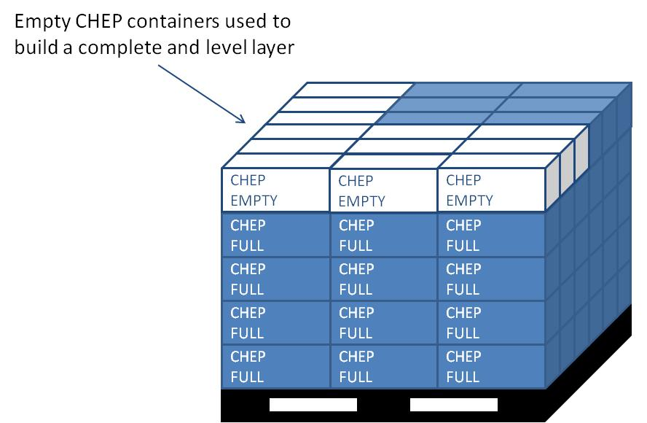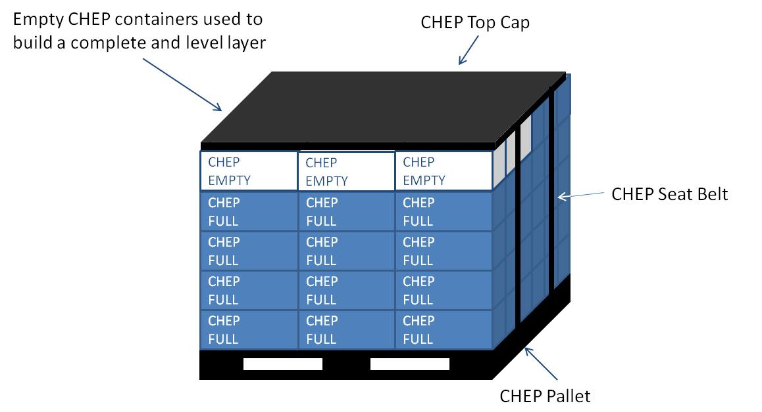

* Only Navistar approved returnable containers can be used for shipments to Navistar assembly plants.
* All returnable containers must be shipped on CHEP pallet and top caps.
* A Navistar-approved top cap must be applied to all pallets so that other pallets can be stacked on top.
* All pallets must have one skid manifest attached, which clearly displays the contents.
* Each container may only carry one part number worth of parts.
* Containers must not over hang the edges of the pallet. Allowing them to do so could result in container damage and eventually part damage from continued abuse.

**Program Standard Containers**

|  |  |  |  |  |  |  |
| --- | --- | --- | --- | --- | --- | --- |
| **CHEP Equipment Type** | **Navistar Container #** | **QTY / Unit Load** | **Description** | **Stack Empty** | **Stack Full** | **Notes** |
|
|
| 12x7x5 Hand Held Tote | CHEP120705 | 216 | Nominal Dimensions: 12”x7”x5” |  |  | Unit Load 6500: 1207-05 (1 Pallet; 216 Totes; 1 Lid) x 4 (Logistics requirement 2 spaces 2 high)  24 / layer – 9 layers / UL |
| Weight: 1.2lbs |
| Volume(cu ft): .13 |
| 12x15x7.5 Hand Held Tote | CHEP121507 | 72 | Nominal Dimensions: 12”x15”x7.5” |  |  | Unit Load 6502: 1215-07 (1 Pallet; 72 Totes; 1 Lid) x 4 (Logistics requirement 2 spaces 2 high)  12 / layer – 6 layers / UL |
| Weight: 2.6lbs |
| Volume(cu ft.): .56 |
| 24x15x7.5 Hand Held Tote | CHEP241507 | 36 | Nominal Dimensions: 24”x15”x7.5” |  |  | Unit Load 6504: 2415-07 (1 Pallet; 36 Totes; 1 Lid) x 4 (Logistics requirement 2 spaces 2 high)  6 / layer – 6 layers / UL |
| Weight: 4.6lbs |
| Volume(cu ft.): 1.09 |
| 24x22.5x11 Hand Held Tote | CHEP242211 | 16 | Nominal Dimensions: 24”x22.5”x11” |  |  | Unit Load 6505: 2422-11 (1 Pallet; 16 Totes; 1 Lid) x 4 (Logistics requirement 2 spaces 2 high)  4 / layer – 4 layers / UL |
| Weight: 7.8lbs |
| Volume(cu ft.): 2.56 |
|  |
| 48x15x7.5 Hand Held Tote | CHEP481507 | 18 | Nominal Dimensions: 48”x15”x7.5” |  |  | Unit Load 6514: 4815-07 (1 Pallet; 18 Totes; 1 Lid) x 4 (Logistics requirement 2 spaces 2 high)  3 / layer – 6 layers / UL |
| Weight: 8.9 lbs |
| Volume(cu ft.): 2.30 |
|  |
| 32x30x25 Bulk Container | CHEP323025 |  | Collapsible bulk container with two access doors & four-way entry base. | **Static:** | **Static:** | Unit Load 6515: 3230-25 (1 FLC Bulk) x 24 (Logistics requirement 3 spaces 8 high)  1 / Layer – 6 Layer / UL |
| Nominal Dimensions: 32” x 30” x 25” | 16 high | 8 high |
| Collapsed Height: 13.1 inches |  |  |
| Weight: 68 lbs. | **Transport** | **Transport** |
| Capacity: 1,800 lbs | 8 high | 4 high |
| 48x45x34 Bulk Container | CHEP484534 |  | Collapsible bulk container with two access doors & four-way entry base. | **Static:** | **Static:** | Unit Load 6506: 4845-34 (1 FLC Bulk) x 18 (Logistics requirement 2 spaces 9 high)  1 / Layer – 6 Layer / UL |
| Nominal Dimensions: 48” x 45” x 34” | 16 high | 6 high |
| Collapsed Height: 13 inches |  |  |
| Weight: 128 lbs | **Transport** | **Transport** |
| Capacity: 2,000 lbs | 8 high | 3 high |
| 48x45 Pallet | CHEPPLT | 5 of each | Plastic Pallet w/ Seat Belt |  |  | Unit Load 6513: PLT & LID (5 Pallet; 5 Lid) x 2 (Estimated maximum additional pallet / lid requirement) |
| Nominal Dimensions: 48”x45”x6” |
| Weight: 72 lbs |
| Capacity: 4,000 lbs dynamic, 30,000lbs static |
| 48x45 Lid | CHEPLID | Pallet Top Cap w/ Seat Belt |  |  |
| Nominal Dimensions: 48”x45”x1” |
| Weight: 20 lbs |