
Navistar International Standard Identification Tag  FOR PACKAGING PART NUMBER _______________________ |  |  |  |  |  |  | Packaging  Specifications
 |  |  |  |  |  |  | No. 7-RP
Product Identification Tags
Affix product identification tag IN1015C (4”x 2”) to part in a secure manner. |  |  |  |  |  |  | Regardless of brand identification tag requirements, all individual bar code tags must include bar code 39 (with ANSI Fact 1 identifiers) and human readable form for:
Corporate Identifier | Quantity-16 pt, bold  Description-9 pt Country of Origin-6 pt |  |  | Age  Code-6 pt |  |  | - ATA/VMRS corporate identifier/manufacturer’s name code. (All International assigned numbers will use ATA/VMRS code INT. This code would be replaced by your code when shipping your part number.)
High Density Bar Code  Part Number-16 pt, bold  (ALL POINT SIZES ARE MINIMUM REQUIREMENTS.) |  |  |  |  |  |  | - The complete ordered part number including all prefixes and suffixes assigned.
When the quantity is one, the word “one” is used. If the quantity is greater than one, the numeral is to be used. Example of an International® part number follows:  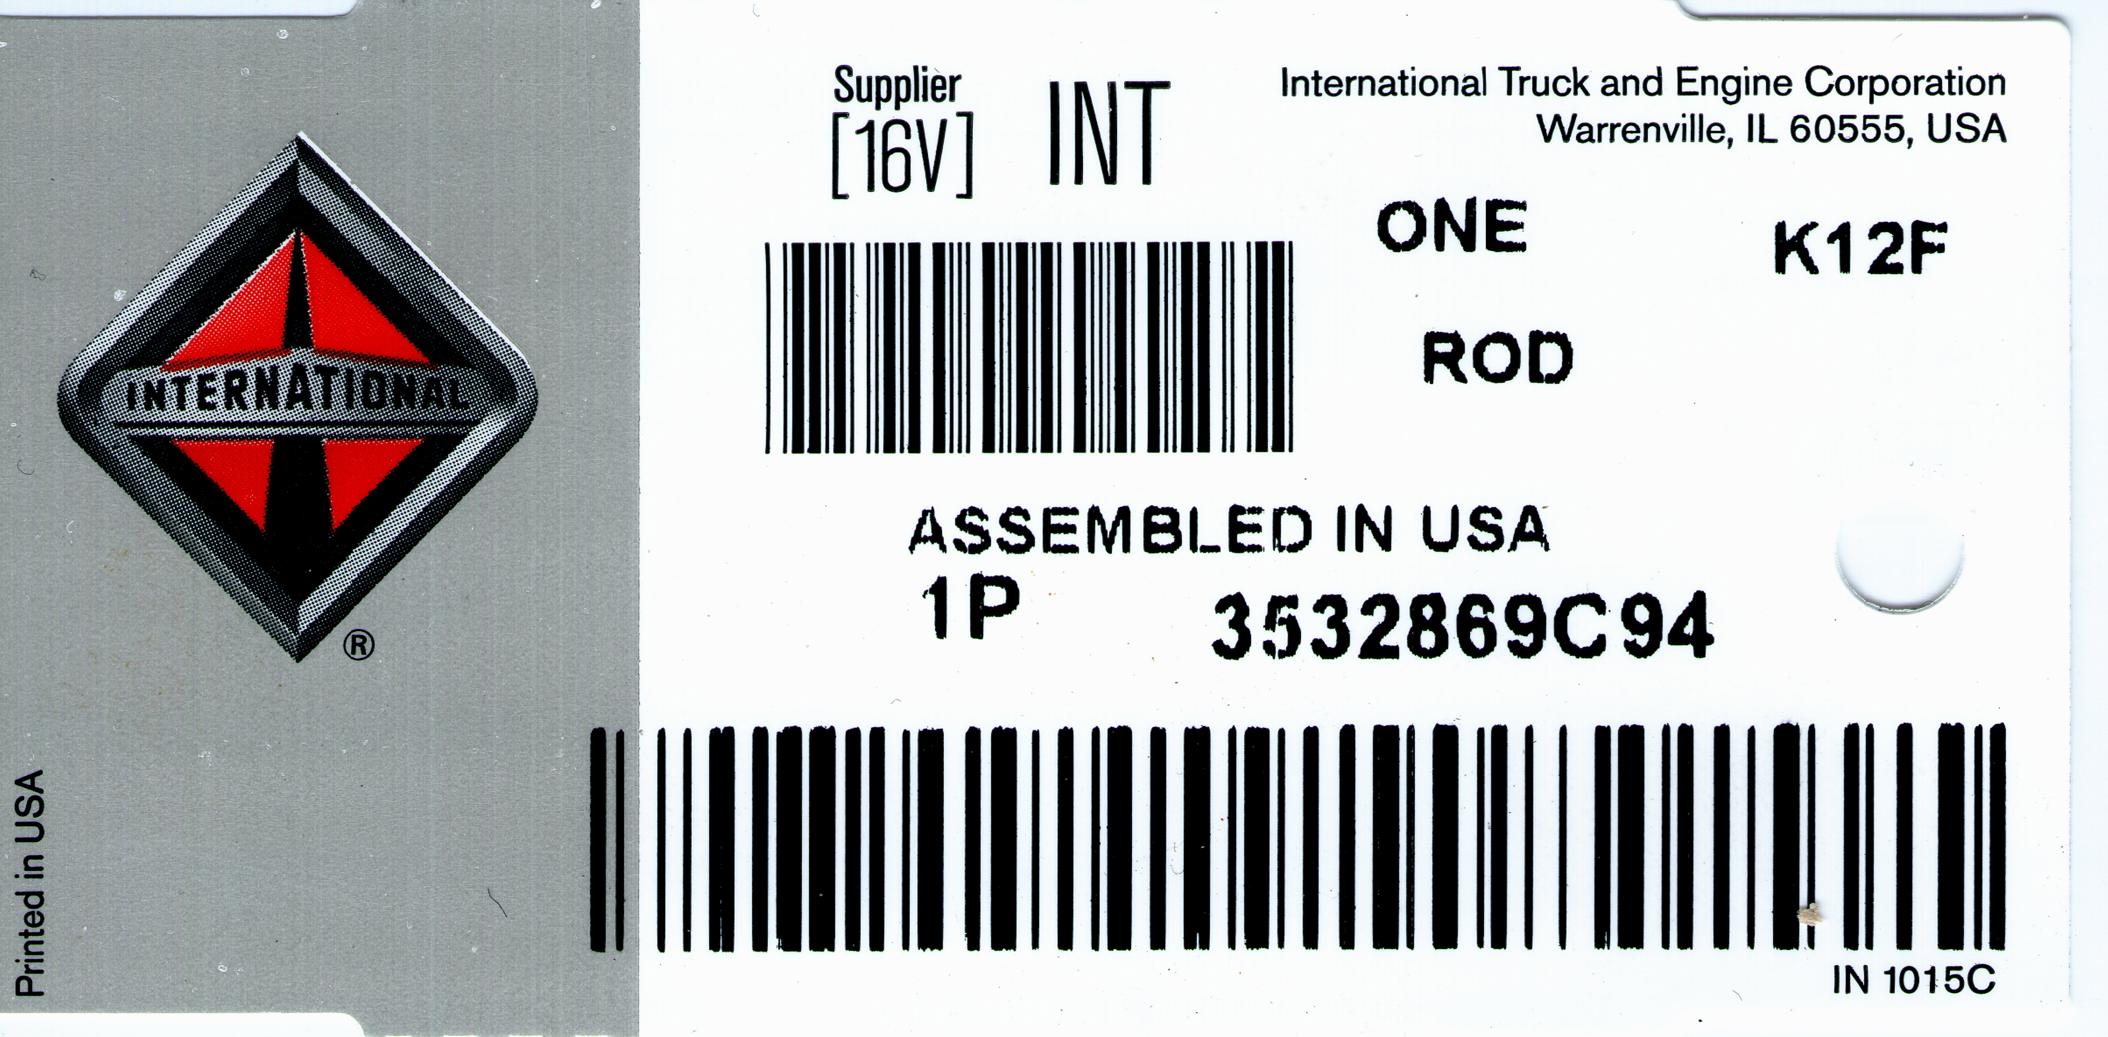 |  |  |  |  |  |  | - Other human readable copy as described in the example. Since most of our part numbers exceed 10 positions, the stacked bar code version is preferred. For shorter part numbers, the concatenated bar code version may be used as defined in the RP801C standard.
 |  |  |  |  |  |  | Other branded tags may be specified for a product line. These tags may be obtained from our source of supply as currently defined.
All individual parts are to be unitized in shipping cartons or stretch wrapped and marked per the
AIAG-B-10 Shipping Carton Standards or superseding standard.
 |  |  |  |  |  |  | CAUTION: When AIAG-B-10 shipping parts labels and/or destination labels are used, the labels must not be applied to the retail unit part.
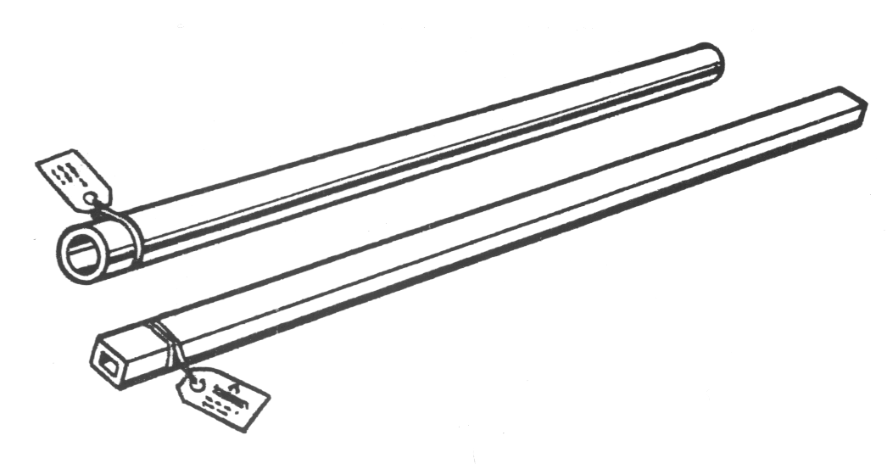 |  |  |  |  |  |  | COUNTRY OF ORIGIN: Products manufactured outside of the USA are required to include “Made in (country)”. Products manufactured within the USA should state “Assembled in USA”.
NOTE: Tag each part and secure with plastic tie or wire.

NOTE: All parts subject to rust must be rust proofed for a minimum protection of one year of storage.
Tag stock is to meet or exceed the following:
Smudge-Proof Tag Stock Thermal Transfer
Type: C-64438 8 Mil Thick
 |  |  | Target
Basis Weight  (lbs./rm. 25x38-500 |  |  | 120.6
Caliper (mils) |  |  | 8.3
Dry Tensile (lbs./in.) |  | MD  CD | 60.00  156.0
Elmendorf Tear  (g/16 sht.) |  | MD  CD | 111  49
Sheffield Smoothness |  | C/S | 5

