

Fleetrite Identification Tag Packaging Specification |  |  |  |  |  | No. 7-F
Affix product identification tag FR1015D to part in a secure manner. |  |  |  |  |  | Regardless of brand identification tag requirements, all individual bar code tags must include bar code 39 (with ANSI Fact 1 identifiers) and human readable form for:  - ATA/VMRS corporate identifier/manufacturer’s name code. (All International assigned numbers will use ATA/VMRS code INT. This code would be replaced by your code when shipping your part number.)  - The complete ordered part number including all prefixes and suffixes assigned.  - Other human readable copy as described in the example. Since most of our part numbers exceed 10 positions, the stacked bar code version is preferred. For shorter part numbers, the concatenated bar code version may be used as defined in the RP801C standard.  Other branded tags may be specified for a product line. These tags may be obtained from our source of supply as currently defined.  All individual parts are to be unitized in shipping cartons or stretch wrapped and marked per the  AIAG-B-10 Shipping Carton Standards or superseding standard.  CAUTION: When AIAG-B-10 shipping parts labels and/or destination labels are used, the labels must not be applied to the retail unit part.
Corporate Identifier | Quantity-16 pt, bold  Description-9 pt Country of Origin-6 pt |  | Age  Code-6 pt
High Density Bar Code
Part Number-16 pt, bold
(ALL POINT SIZES ARE MINIMUM REQUIREMENTS.)
When the quantity is one, the word “one” is used. Example of an International® part number follows:

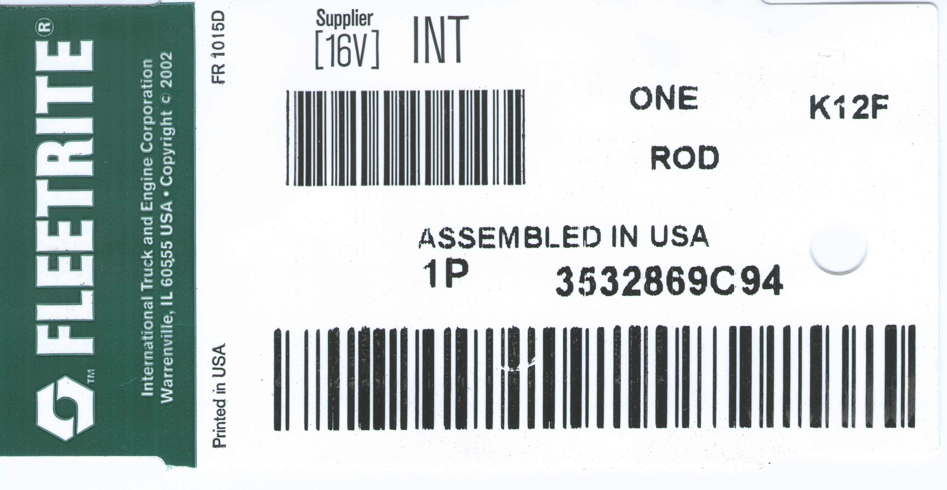
COLOR: White stock; band 7475C Green; Printing 4C Black.

NOTE: Tag each part and secure with plastic tie or wire.

NOTE: All parts subject to rust must be rust proofed for a minimum protection of one year of storage.

COUNTRY OF ORIGIN: Products manufactured outside of the USA are required to include “Made in (Country)”. Products manufactured in the USA are required to specify “Assembled in USA”
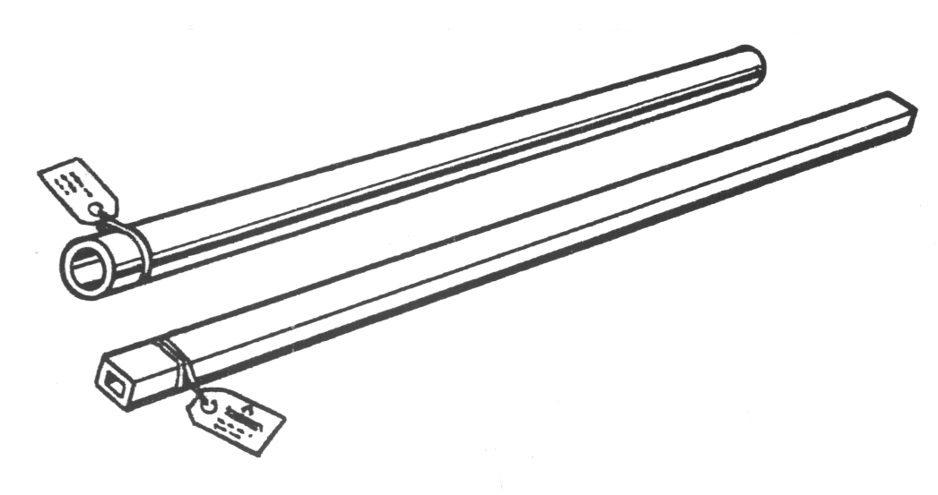
Tag stock is to meet or exceed the following: |  |  |  |  |  | For Packaging Part Number ___________________
Smudge-Proof Tag Stock Thermal Transfer |  |  |  |  |  | Pack ______ pieces of the part number shown above in this crate.
Type: C-64438 8 Mil Thick |  |  |  |  |  | Crate Number: _____________________________
 |  |  |  | Target |  | Size: L ______ W ______ D ______
Basis Weight (lbs./rm. 25x38-500) |  |  |  | 120.6 |  | Remarks______________________________________________________________________________________________________________________________________________________________________________________________________
Caliper (mils) |  |  |  | 8.3
Dry Tensile (lbs./in.) |  | MD  CD |  | 60.00  156.0
Elmendorf Tear  (g/16 sht.) |  | MD  CD |  | 111  49
Sheffield Smoothness |  | C/S |  | 5 |  | All crate should have the standard Navistar, Inc. Shipping and retail label.

